**23CSE111**

**OBJECT ORIENTED PROGRAMMING**

**LAB REPORT**



**Department of Computer Science Engineering**

**Amrita School of Computing**

**Amrita Vishwa Vidyapeetham, Amaravati Campus**

**Name: K.Uday Kiran**

**Verified By Roll No: 24207**

**INDEX**

|  |  |  |  |  |
| --- | --- | --- | --- | --- |
| **SNo** | **Title** | **Date** | **Page No** | **Signature** |
| **WEEK 1** |  |  |  |  |
| 1 | Download and Install Java Software |  |  |  |
| 2 | Write a Java program to print the message “Welcome to Java Programming.” |  |  |  |
| **WEEK 2** |  |  |  |  |
| 1 | Write a Java program to calculate area of rectangle. |  |  |  |
| 2 | Write a Java program to calculate Simple interest. |  |  |  |
| 3 | Write a Java program to calculate factorial of a number. |  |  |  |
| 4 | Write a Java program to calculate fibonacci of a number. |  |  |  |
| 5 | Write a java program to calculate the area of the triangle. |  |  |  |
| 6 .1 | Write a Java program to convert temperature from Celsius to Fahrenheit |  |  |  |
| 6.2 | Write a Java program to convert temperature from Fahrenheit to Celsius |  |  |  |
| **WEEK 3** |  |  |  |  |
| 1 | Write a java program with  1. A class with name Car.  2.Create 4 attributes named car_color , car_brand ,fuel_type ,mileage. 3.Create 3 methods named start() ,stop() ,service(). 4.Create 3 objects named car1 ,car2 ,car3. |  |  |  |
| 2 | Write a java program with 1.Create a class named Bankaccount. 2.Create a constructor. 3.Create 2 methods which are withdrawl() and deposit(). |  |  |  |
| **WEEK 4** |  |  |  |  |
| 1 | Write a java program with class named book. This class should contain various attributes such as title, author ,year of publication. It should also contain a constructor with parameters which initializers title ,author ,year of publication. Create a method which displays the details of the book .Display the details of 2 books. |  |  |  |
| 2 | Create a java program with class named myclass with a static variable count of int type ,initial value to zero and a constant variable "pi" of type double initialize to 3.14 as attributes of that class ,now define a constructor for "myclass" that increments the count variable each time an object of myclass is created. Finally print the values of count and pi variables . Create 3 objects. |  |  |  |
| **WEEK 5** |  |  |  |  |
| 1 | Create a calculator using the operations including addition, subtraction, multiplication, and division using multi-level inheritance and display the desired output. |  |  |  |
| 2 | A vehicle rental company wants to develop a system that maintains information about different types of vechicles available for rent the company rents out cars and bikes, and they need a program to store details about each vehicle, such as brand and speed( should be in super class)  1.cars should have an additional property: no.of doors 2.Bikes should have a property indicating whether they have gears or not. 3.The system should also include a function to display details about each vehicle and indicate when a vehicle is starting. 4.Every class should have a constructor. Question:  1.Which oops concept is used in the above program  2.If the company decides to add a new type of vehicle, Truck, how would you modify the program?  a.Truck should include an additional property capacity (in tons)  b.Create a showTruckdetails() method to display the truck’s capacity.  c.Write a constructor for Truck that initializes all properties Implement the truck class and update the main method to create a Truck object and also create an object for car and bike sub classes Finally, display the details. |  |  |  |
| **WEEK 6** |  |  |  |  |
| 1 | Write a java program to create a vehicle class with a method displayinfo(). Override this method in the car subclass to provide specific information about a car. |  |  |  |
| 2 | Create a calculator class with overloaded methods to perform addition.  A. Add two integers  B. Add two double  C. Add three integer |  |  |  |
| 3 | Create a shape class with a method CalculateArea() that is overloaded for different shapes (e.g square, rectangle) then, create a subclass circle that overrides the calculatearea() method for a circle. |  |  |  |
| 4 | A college is developing an automated admissions systems that verifies students eligibility for undergraduate(UG) and postgraduate(PG) programs. Each program has different eligibility. Criteria based on the students percentage in their previous qualification.  1. UG admission require min of 60%  2. PG admission require min of 70% |  |  |  |

**WEEK 01**

**PROGRAM-1:**

**AIM:** Download and Install Java Software

**PROCEDURE:**

**Step 1: Download JDK 21**

1. Open your web browser and go to the Oracle JDK Downloads page
2. Scroll down to the Java SE Development Kit 21 section.
3. Choose the Windows x64 Installer version.
4. Click on Download, then Wait for the download to complete

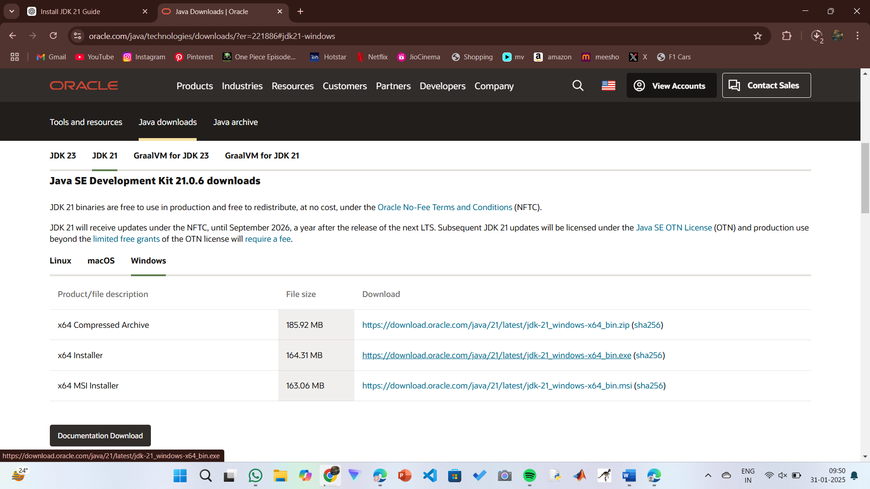

**Step 2:** **Install JDK 21**

1. Locate the downloaded jdk-21_windows-x64_bin.exe file.
2. Double-click to launch the installer.
3. Click Next on the setup wizard.
4. Choose the installation path (default is C:\Program Files\Java\jdk-21).
5. Click Next, then click Install.
6. Wait for the installation to complete.
7. Click Close once the installation is finished.

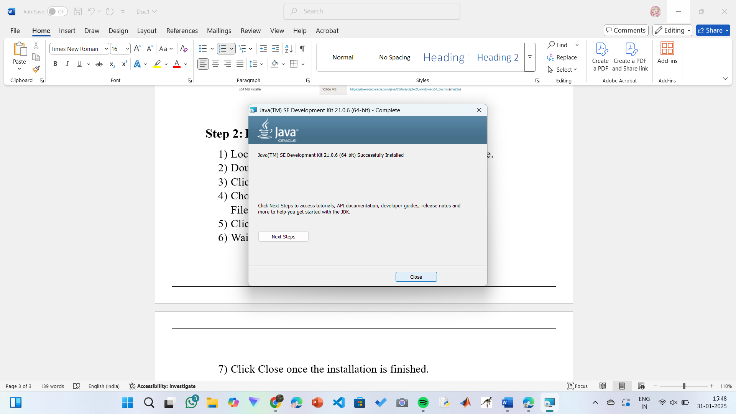

**Step 3: Setting up the path**

1) Go to “Windows C” Drive on Desktop

2) Choose Program Files, select Java, then JDK 21, then select Bin.

3) Select and copy the path at the address bar.

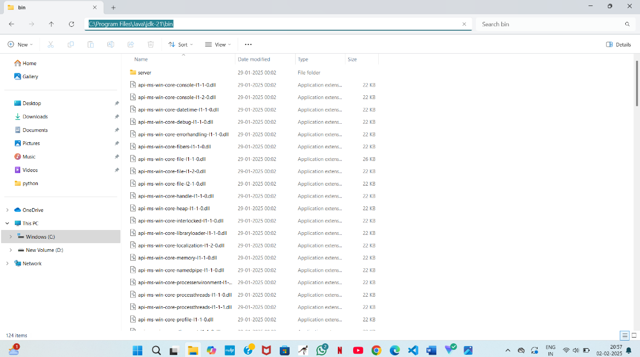

**Step 4: Open System Properties**

1. Press Windows + R, type sysdm.cpl , and click Ok-
2. The System Properties window will open.
3. Navigate to the Advanced tab.
4. Click on Environment Variables at the bottom.

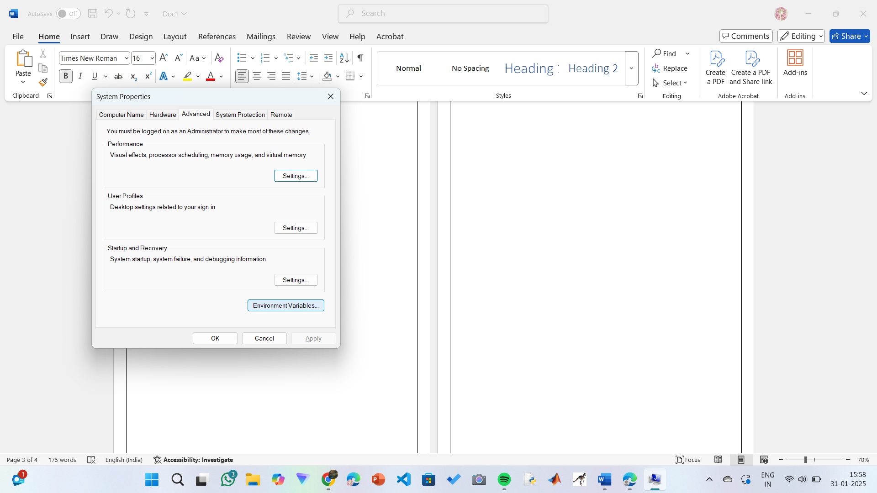

**Step 5: Set JAVA_HOME**

1)Under System Variables, click New.

2)Set the Variable name as JAVA_HOME.

3)Set Variable value as C:\Program Files\Java\jdk-21 (or your installation path).

4)Click OK.

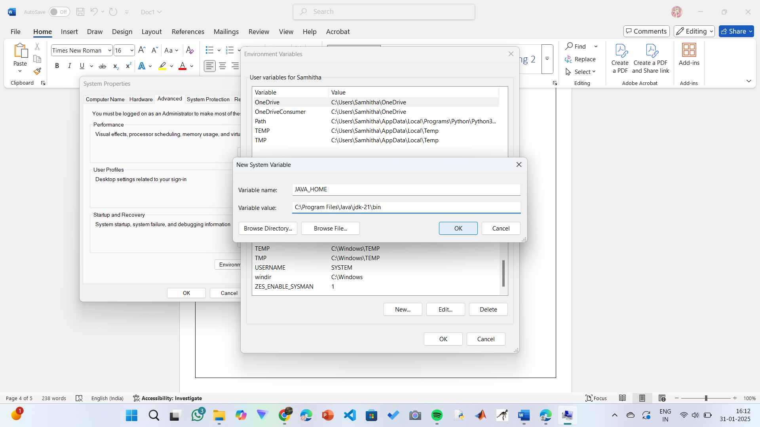

**Step 6: Update PATH Variable**

1)In System Variables, find Path and click Edit.

2)Click New and add: C:\Program Files\Java\jdk-21\bin

3)Click OK to save.

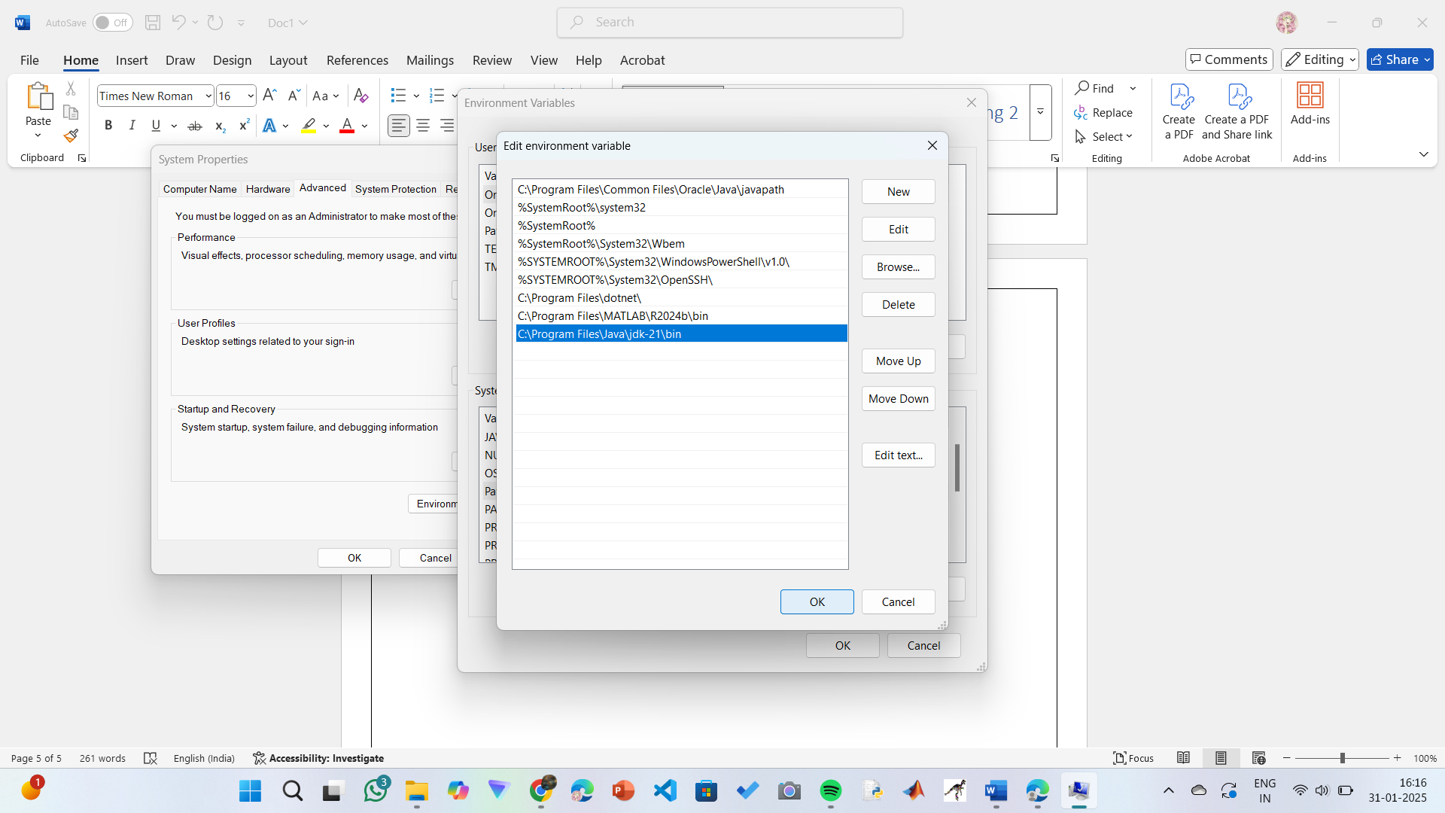

**Step 7:Verify Installation**

1. Open Command Prompt.
2. Type the following command: **java --version** and press Enter.

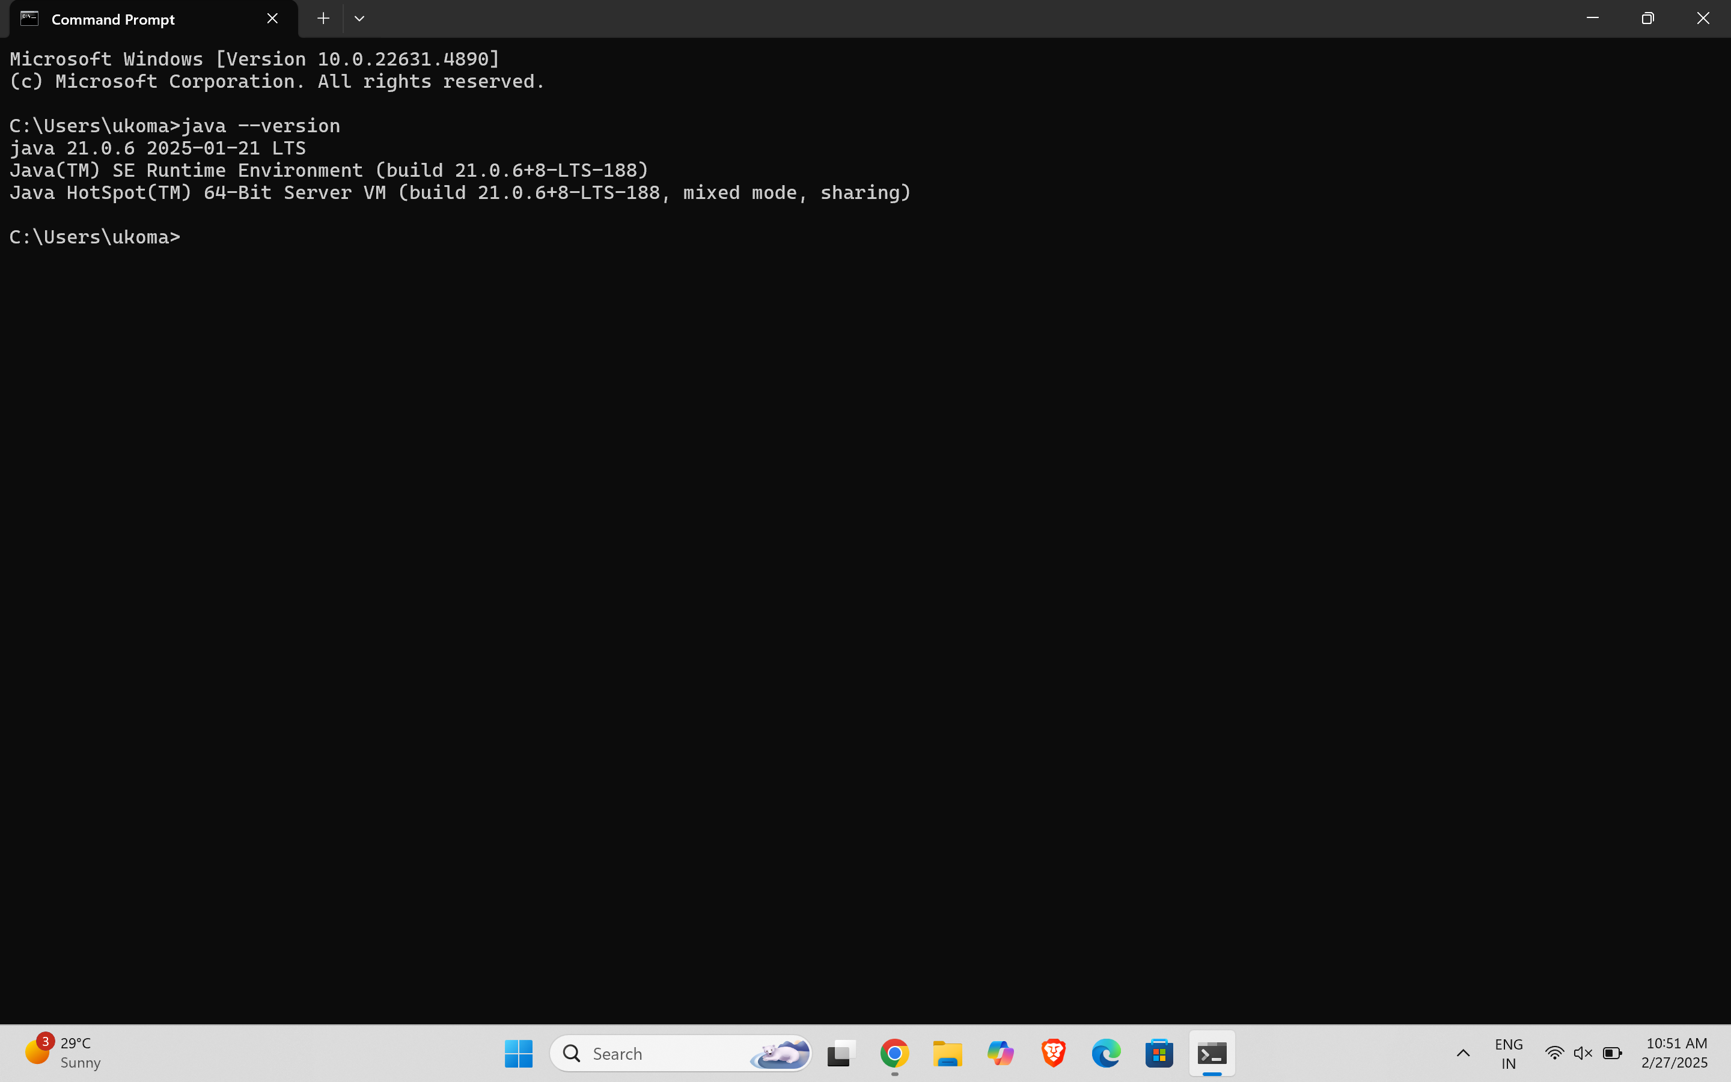

1. To check the java compiler type: **javac –version.**

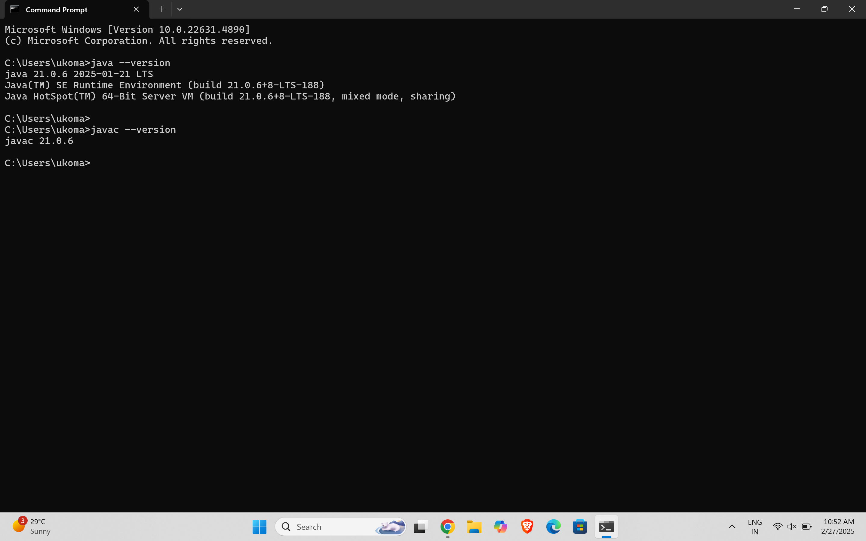

**PROGRAM-2:**

**AIM:** Write a Java program to print the message “Welcome to Java Programming.”

**CODE:**

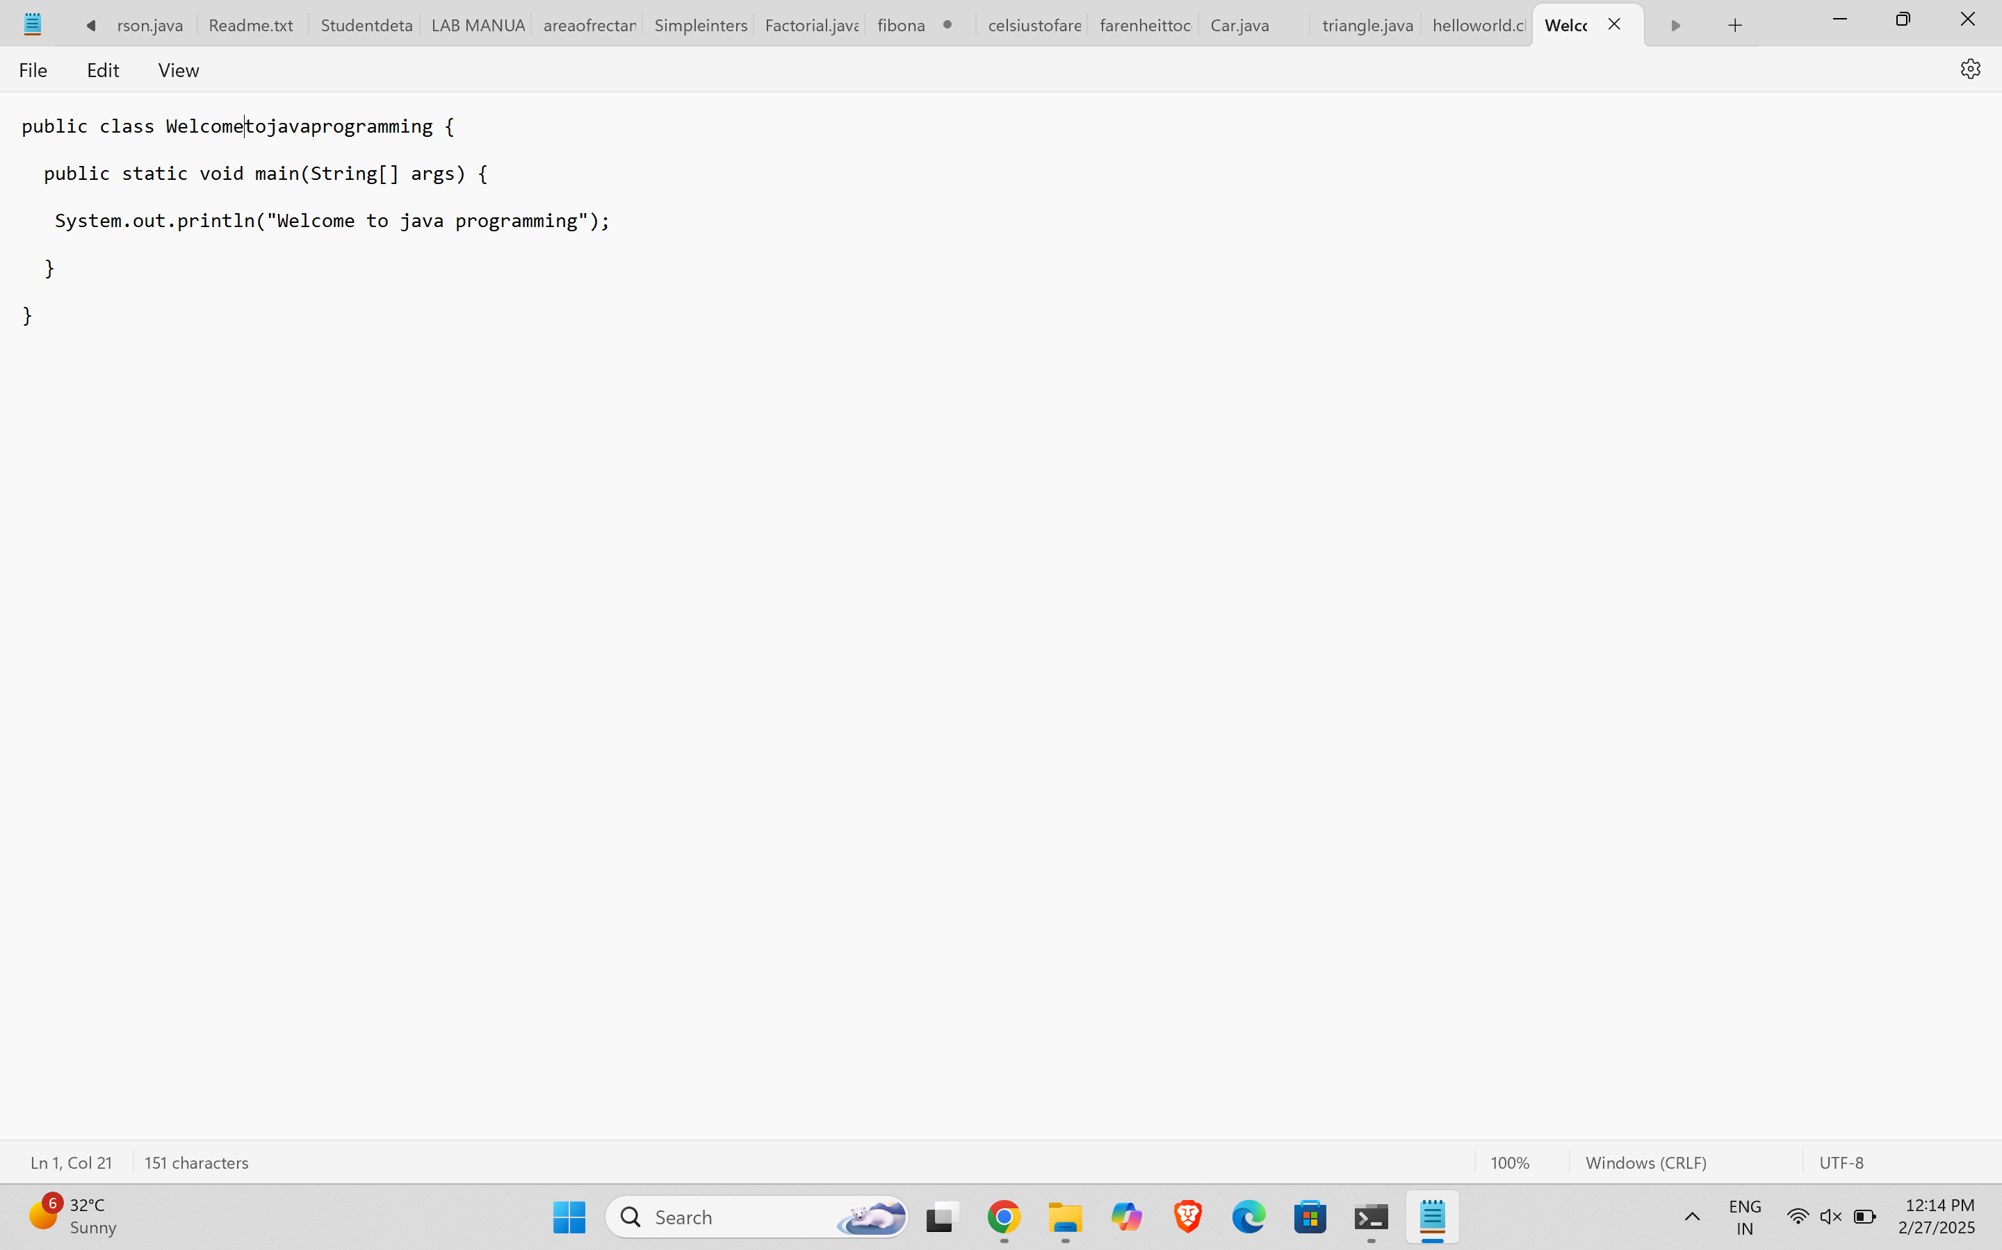

**Output:**

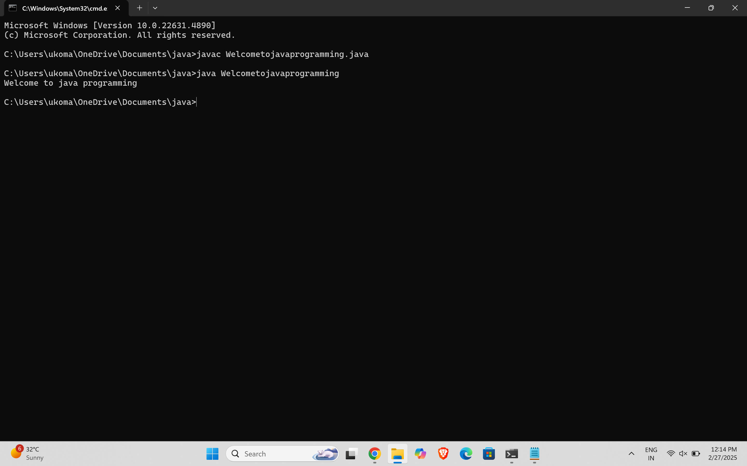

**ERRORS:** None found

**PROGRAM-3:**

**AIM:** Write a Java Program that prints Name, Roll No, Section of a student.

**CODE:**

**STUDENT DETAILS:**

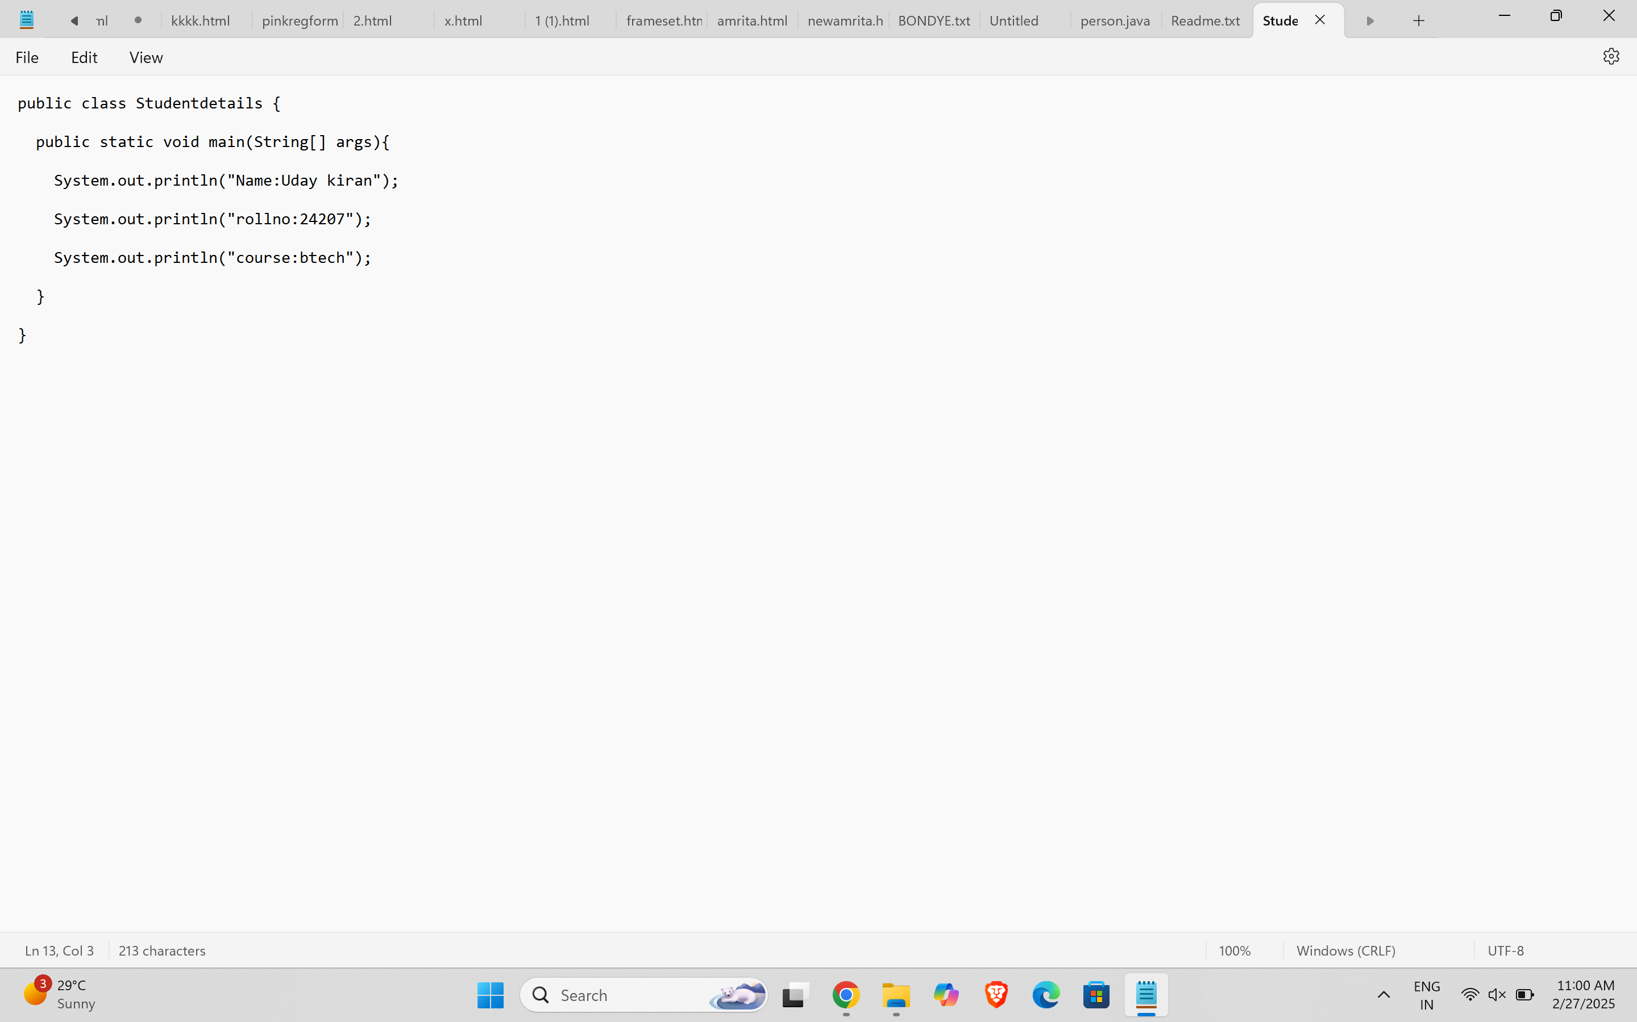

**OUTPUT:**

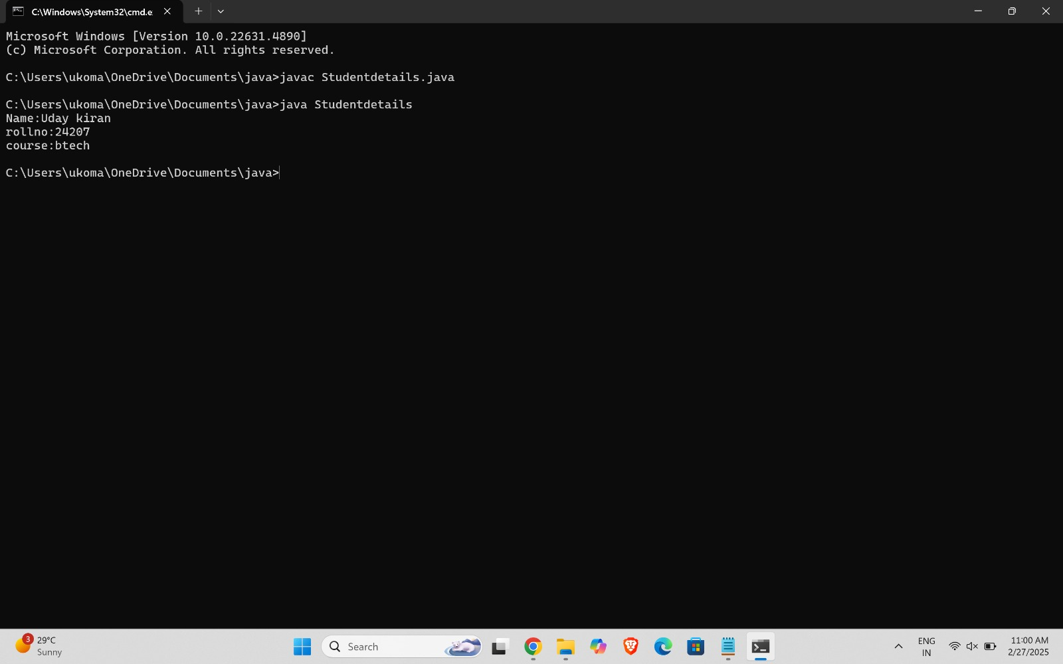

ERROR TABLE:

|  |  |
| --- | --- |
| **Code Error** | **Code rectification** |
| 1. writing small “S”in place of”S”   In system.out.println()  2)not giving strings to the name and scetion | 1. code is rectified by keeping capital “S” 2. Giving strings to name and section |

**IMPORTANT POINTS:**

* Use System.out.println() correctly (capital "S" in System).
* Ensure Name, Roll No, and Section are enclosed in double quotes.

**WEEK-2:**

AIM: Write a java program to find the Area of a rectangle, where all the inputs are taken from the user.

**CODE:**

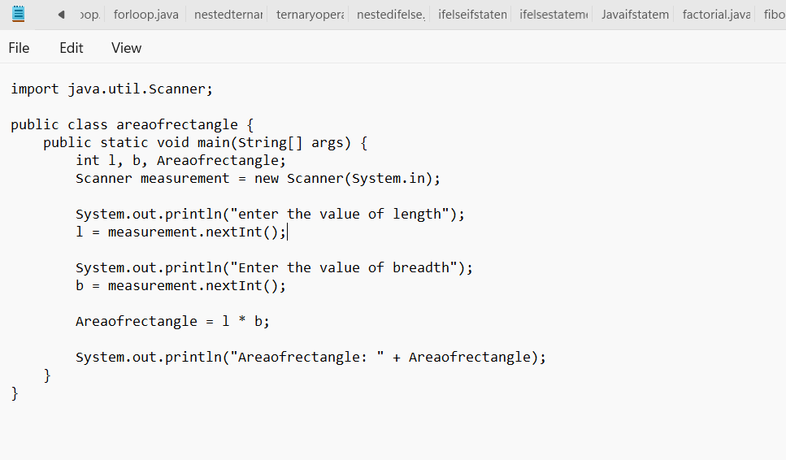

**OUTPUT:**

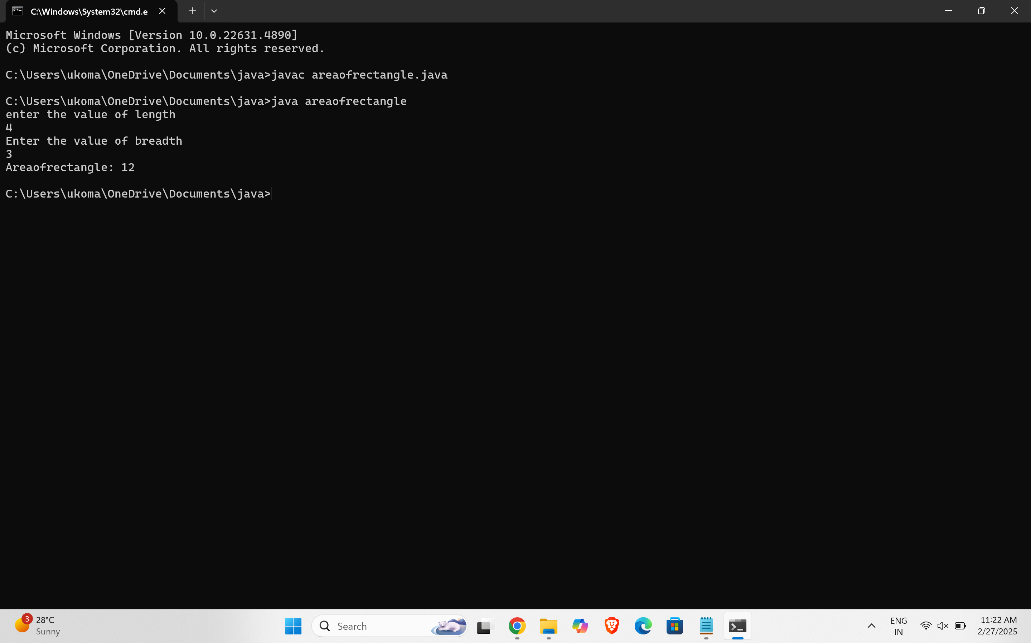

ERROR TABLE:

|  |  |
| --- | --- |
| **Code Error** | **Code rectification** |
| 1. While using for iteration, not giving the conditions correctly. 2. Declaring the data type as double instead of int. | 1. We should give iterative statements correctly. 2. We should give the data type as int for integers. |

**IMPORTANT POINTS:**

* Use the formula: **Area = length × breadth**.
* We must be sure that all conditions inside for loop must be given correctly

**2.AIM:** Write a java programme to calculate Calculate the simple interest

**CODE:**

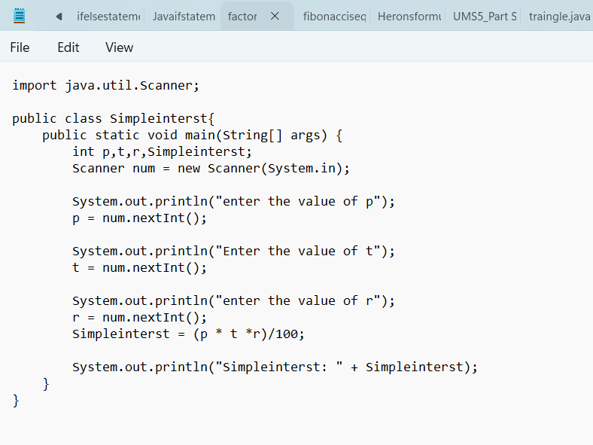

**OUTPUT:**

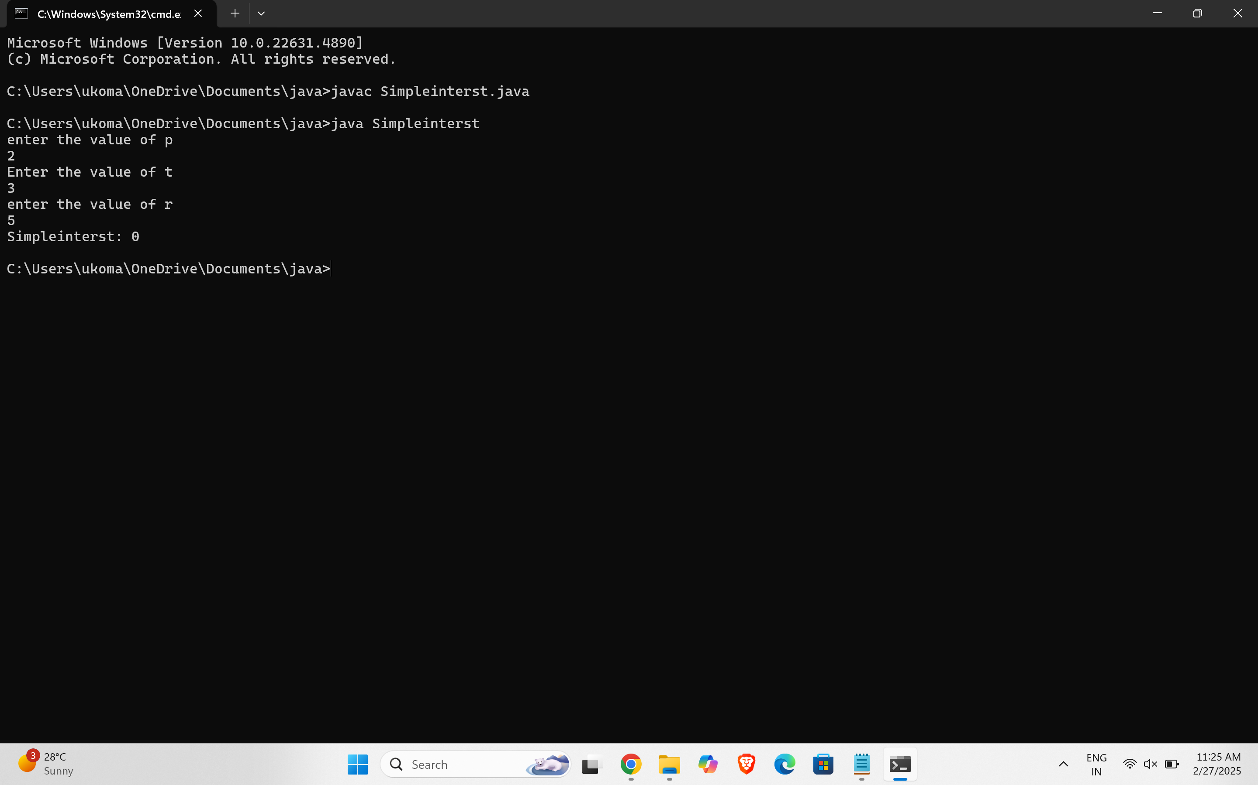

ERROR TABLE:

|  |  |
| --- | --- |
| **Code Error** | **Code rectification** |
| 1. Giving space between next and Double. 2. Not giving parenthesis after closing the input. | 1. Should not give space between next and Double. 2. We must put parenthesis after closing the input. |

**IMPORTANT POINTS:**

* Use the formula: **SI = (P × R × T) / 100** (P = Principal, R = Rate, T = Time).
* The statement **"import java.util.Scanner"** serves the following purpose:
* **import**: Informs the Java compiler that a specific class or package is required in the code.
* **java.util**: Refers to the package that contains various utility classes, including those for handling input and output.
* **Scanner**: A class that enables reading input from the user via the keyboard.

**3.AIM:** Write a java programme to calculate Factorial of N

**CODE:**

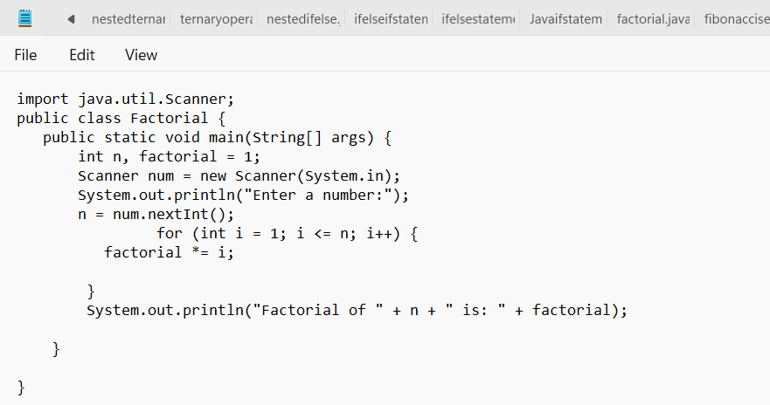

**OUTPUT:**

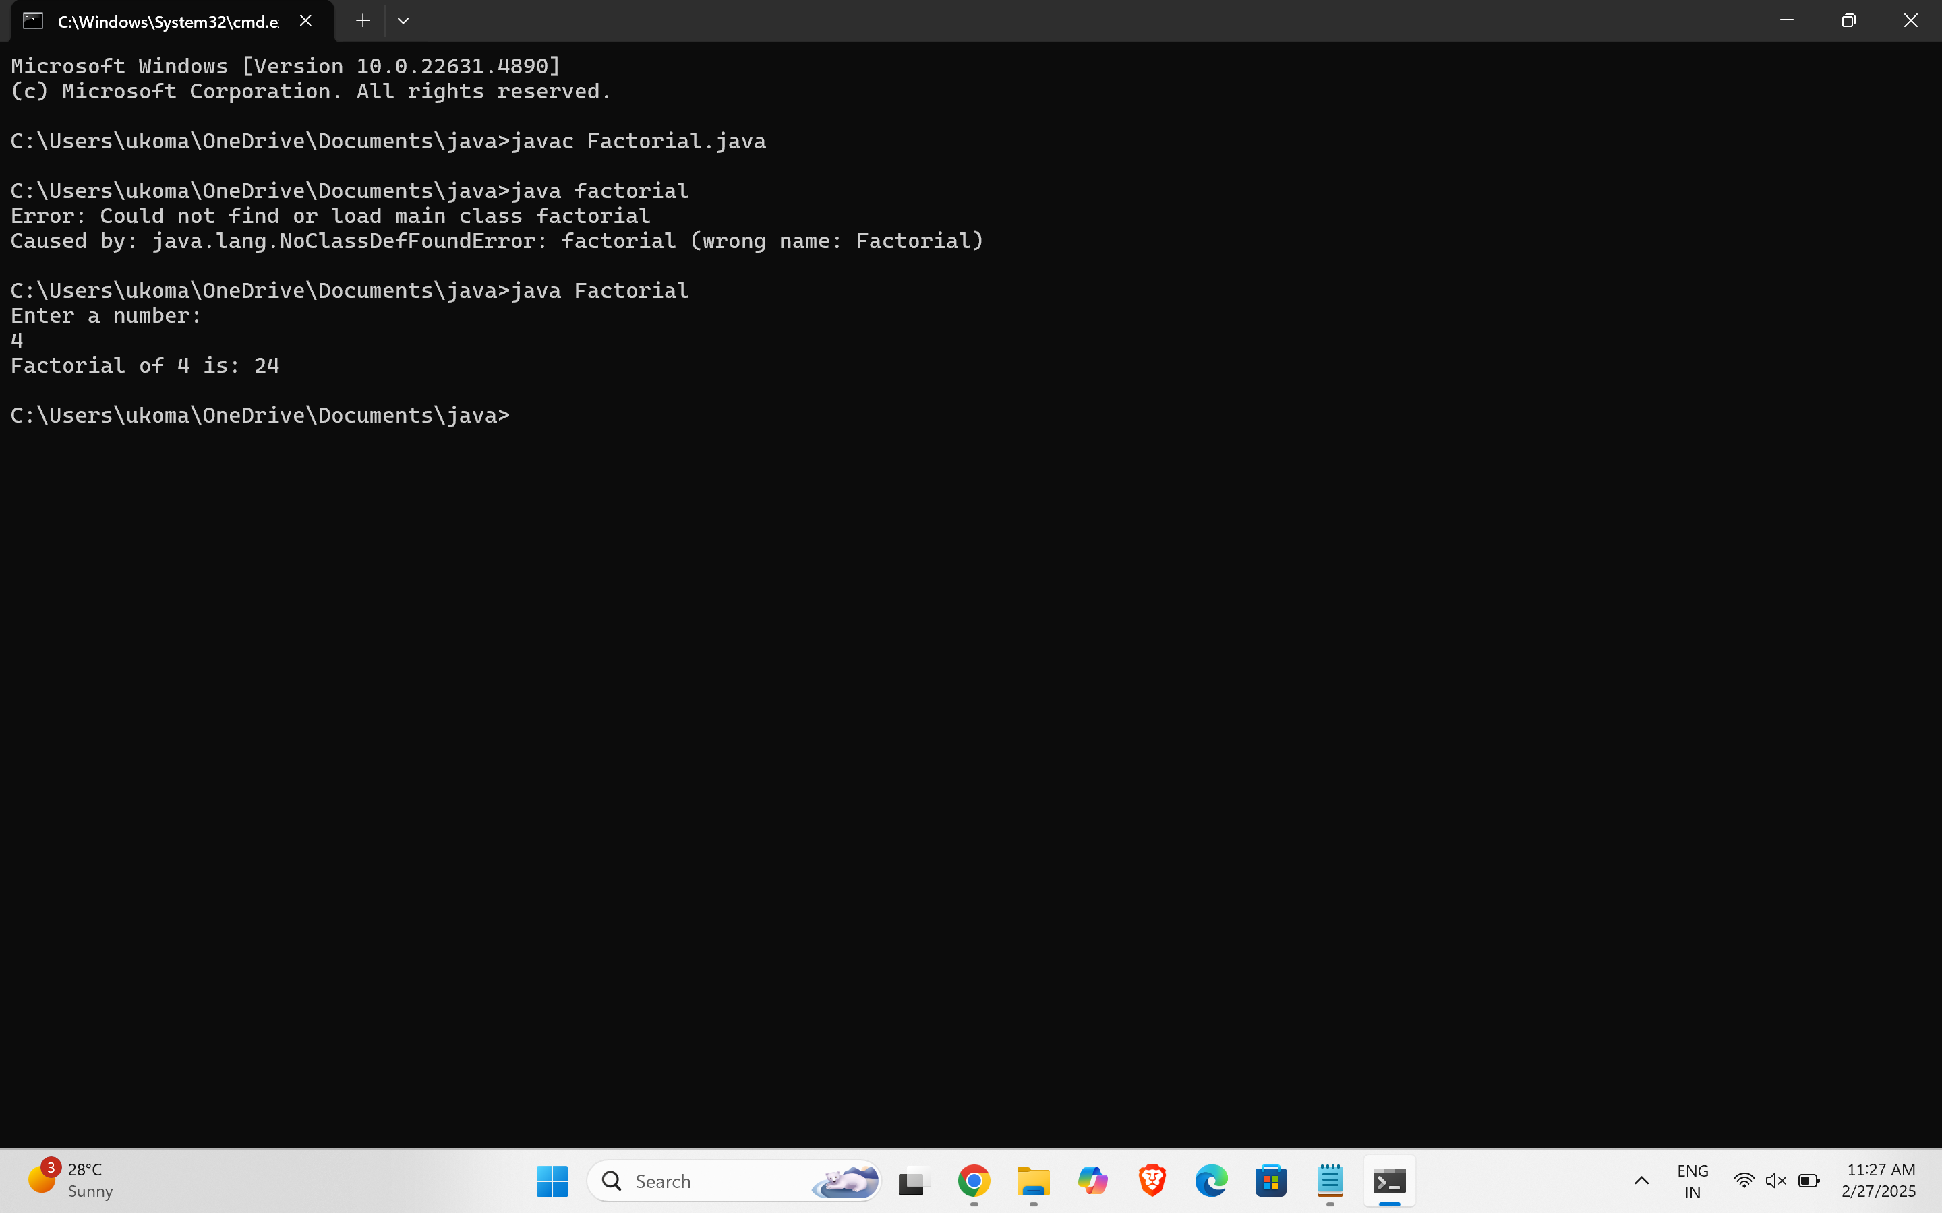

ERROR TABLE:

|  |  |
| --- | --- |
| **Code Error** | **Code rectification** |
| 1. While using for iteration, not giving the conditions correctly.  2.Declaring the data type as double instead of int. | 1.We should give iterative  statements correctly.  2.We should give the data type as int for integers. |

**IMPORTANT POINTS :**

* **Here are we are using datat type “int” to calculate the integer values**
* **It dosent support floating points**

**4.AIM:** Write a java programme to calculate fibonacci sequence

**CODE:**

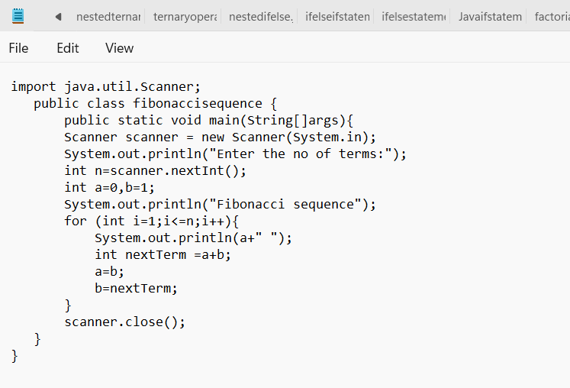

**OUTPUT:**

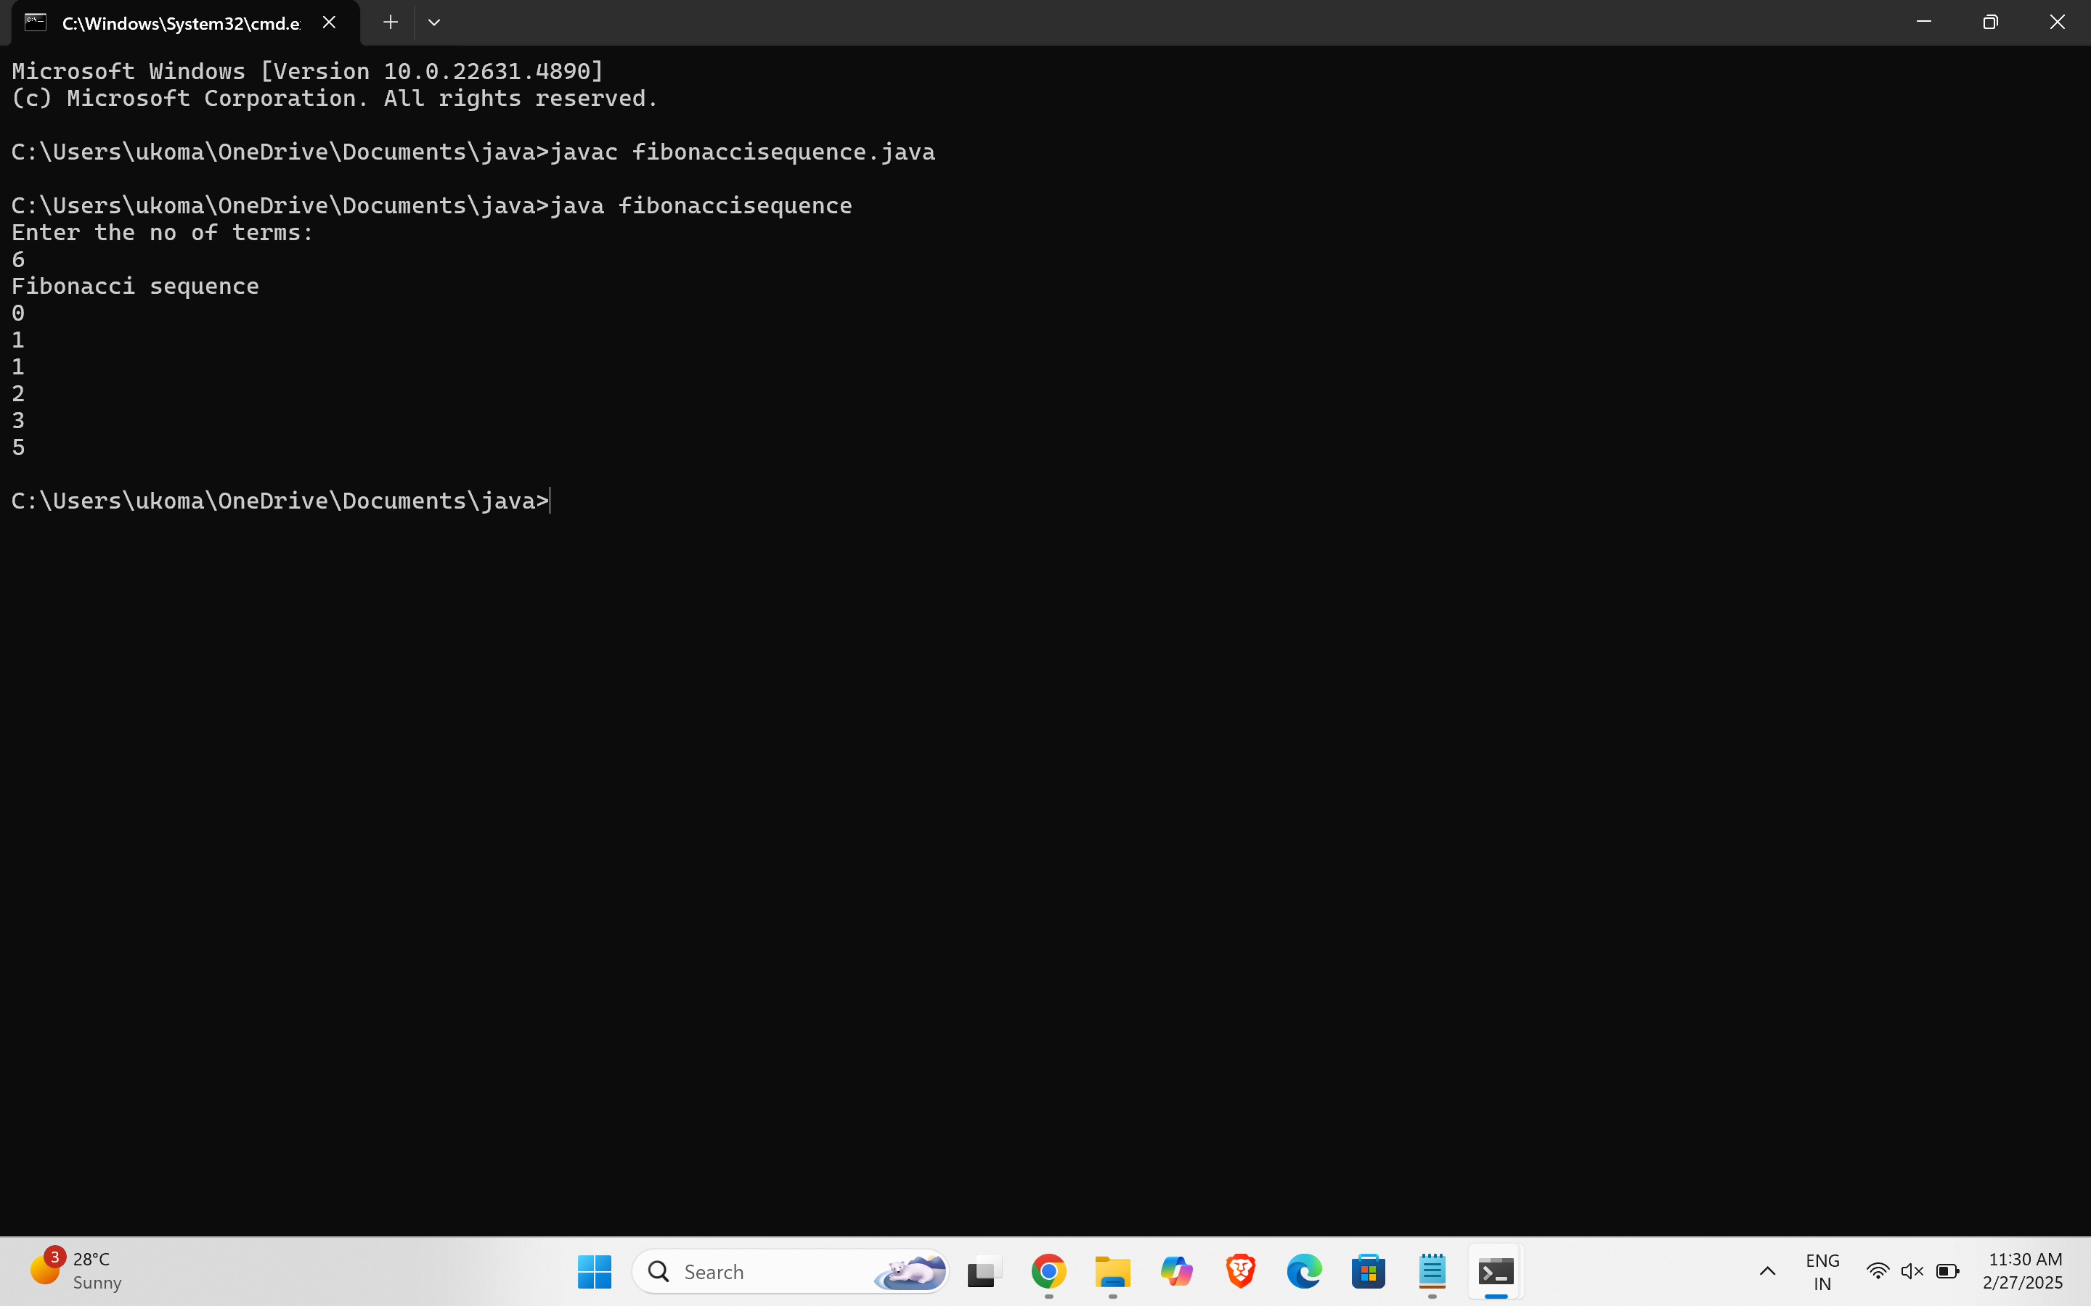

ERROR TABLE:

|  |  |
| --- | --- |
| **Code Error** | **Code rectification** |
| 1. Giving space between next and Double. 2. Not giving parenthesis after closing the input. | 1. Should not give space between next and Double. 2. We must put parenthesis after closing the input. |

**IMPORTANT POINTS:**

* Use import java.util.Scanner; to take user input.
* Here sum value is given to second variable, second is given to first variable

**5.AIM**: Write a java programme to calculate Area of triangle using herons formula

**CODE:**

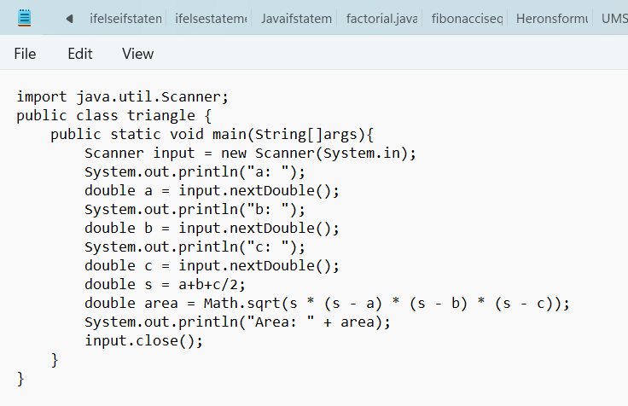

**OUTPUT:**

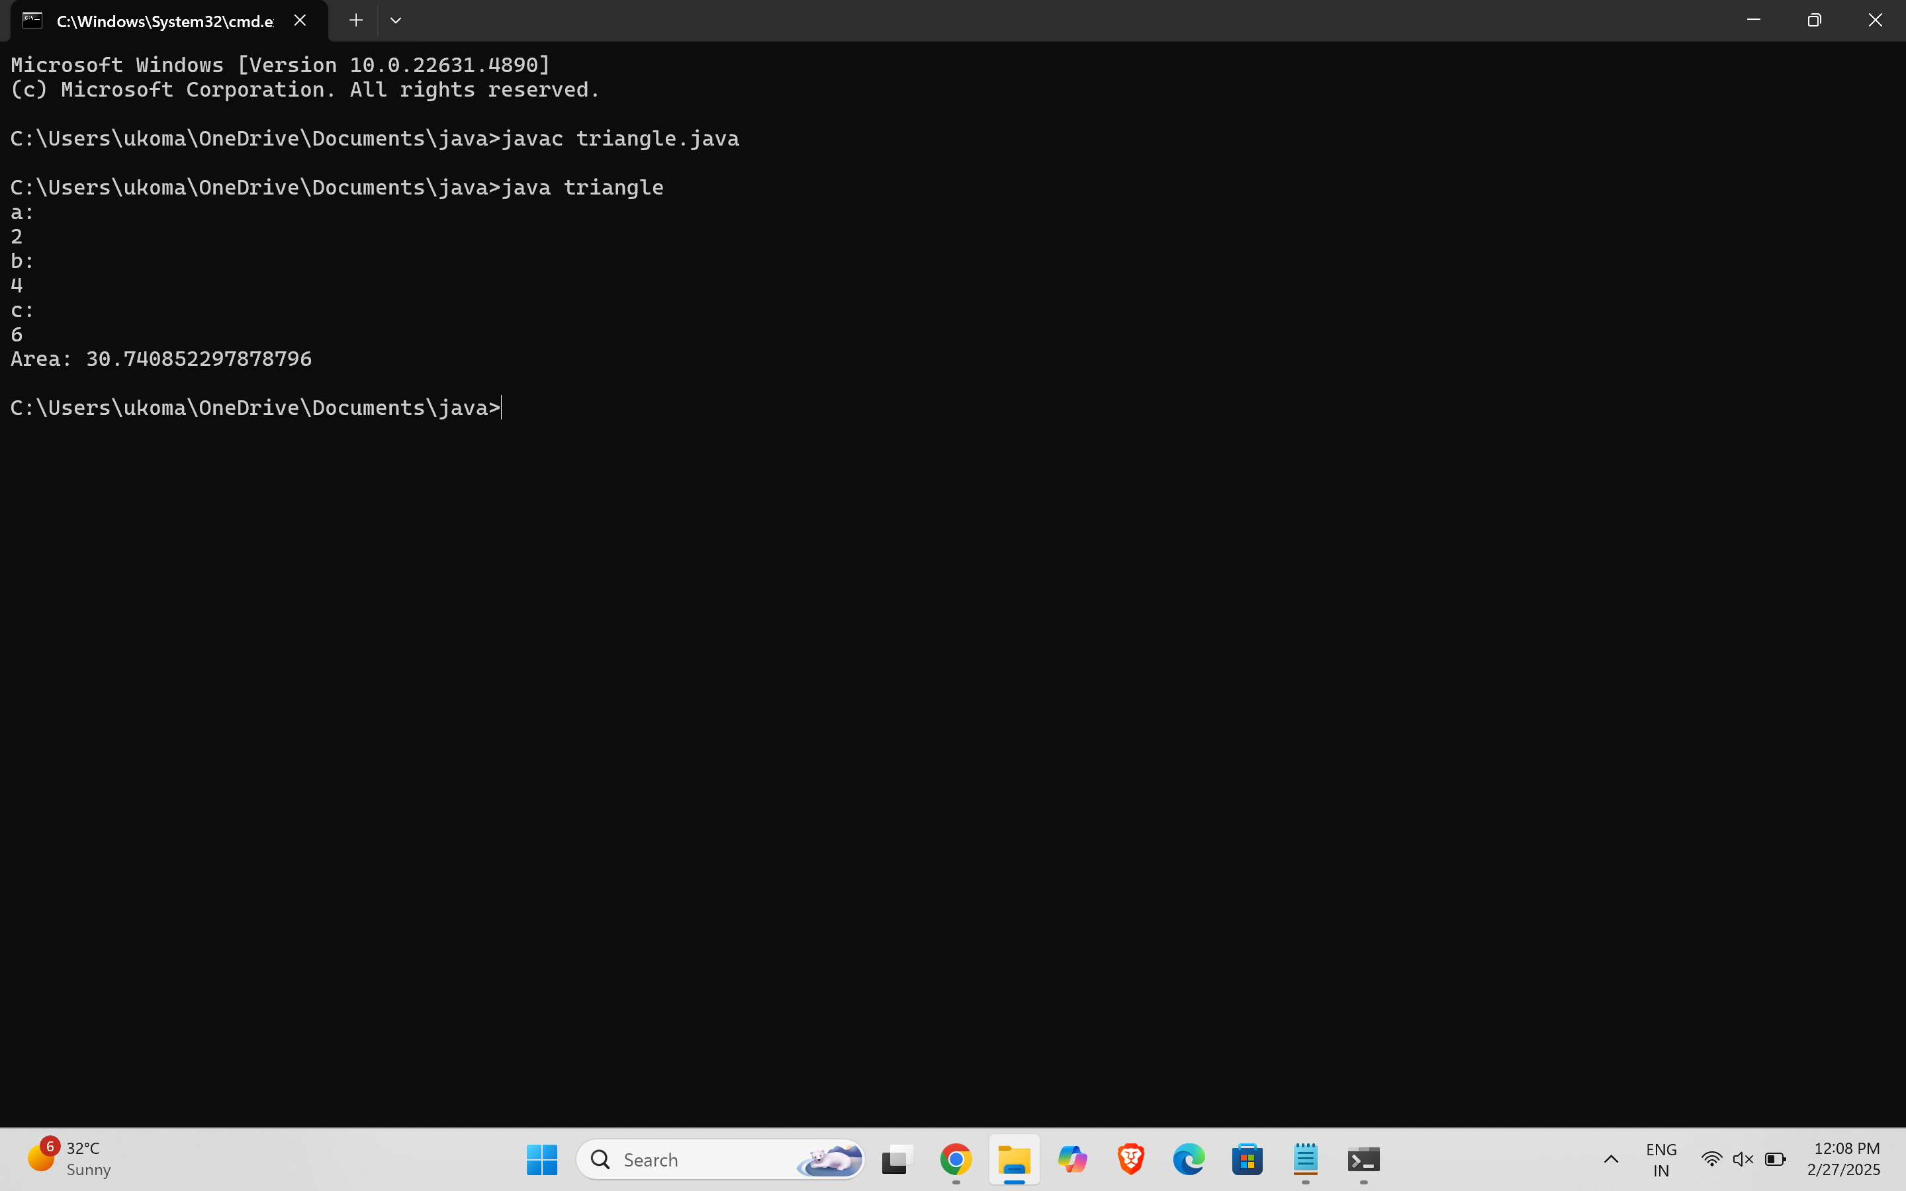

ERROR TABLE:

|  |  |
| --- | --- |
| **Code Error** | Code rectification |
| 1. While printing the variable not giving + sign. 2. Not closing the scanner. | 1. We should give correct indentation. 2. Closing the scanner is must. |

**IMPORTANT POINTS:**

* Use Scanner to take input for base and height.

*We use herons formula to find area of triangle (S=(a+b+c/2))

6)AIM: Write a java program to convert the temperature from Celsius to Fahrenheit and Celsius to Fahrenheit.

**CODE:**

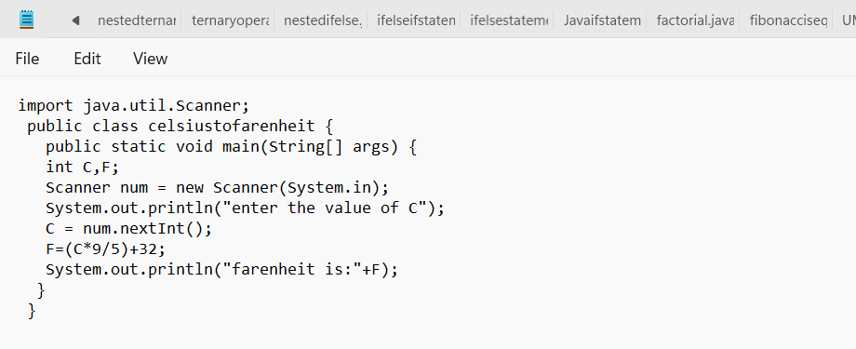**OUTPUT:**

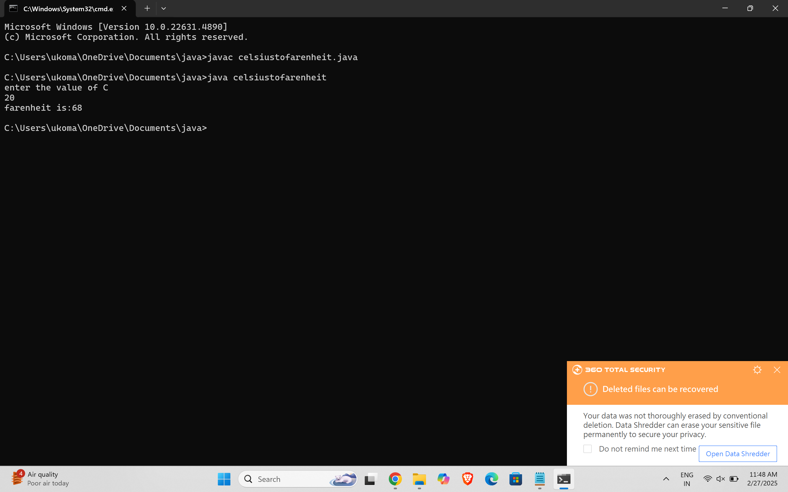

**II.) AIM:** Write a java programme to calculate Convert temperature Fahrenheit to

celsius

**CODE:**

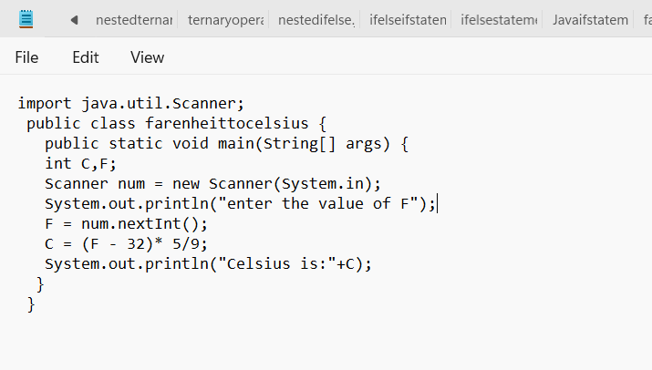

**OUTPUT:**

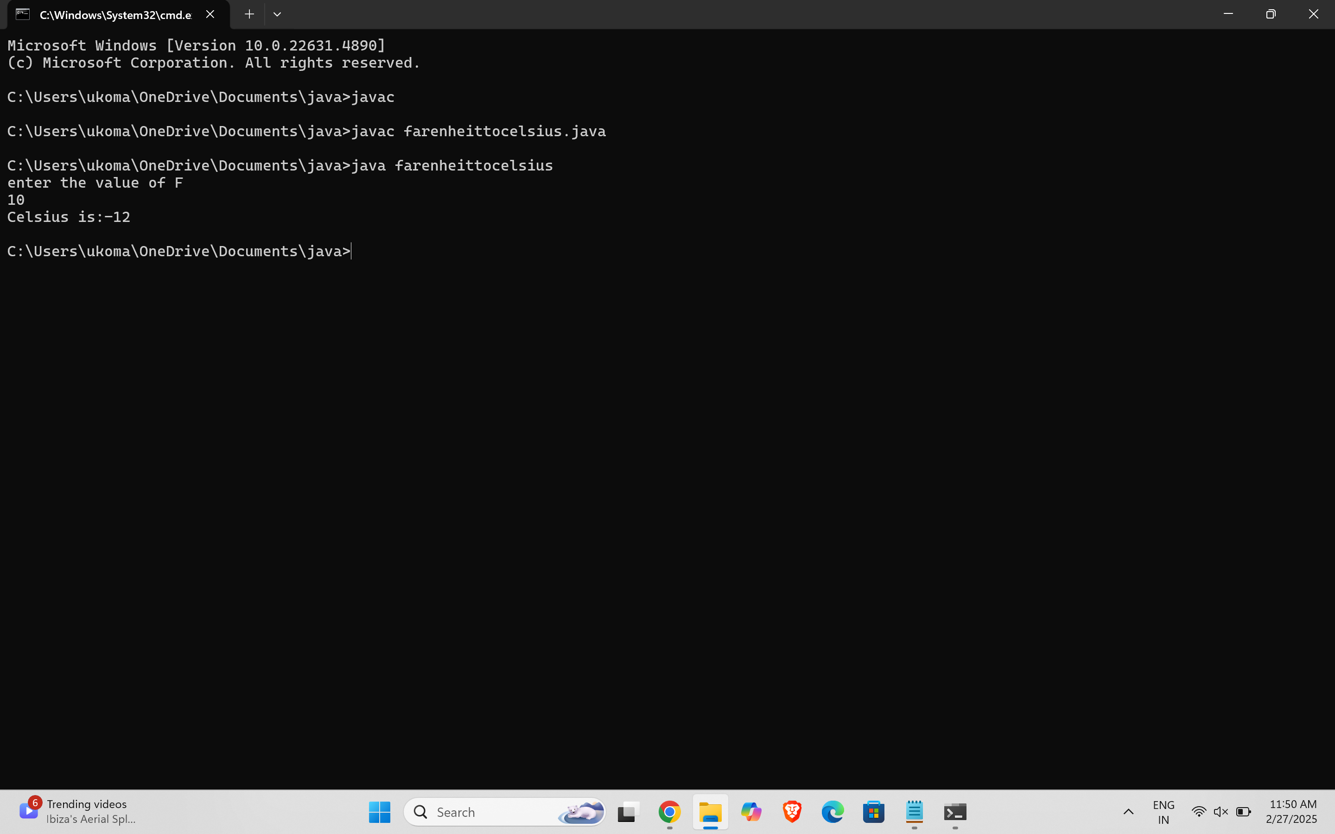

ERROR TABLE:

|  |  |
| --- | --- |
| **Code Error** | **Code rectification** |
| 1. While printing the variable not giving + sign. 2. Not closing the scanner. | 1. We should give correct indentation. 2. Closing the scanner is must. |

**WEEK -3:**

**AIM:**

To create java program with following instructions :

1. Create a class with name Car

2. Create four attributes named car_color, car_brand, fuel_type, mileage

3. Create these methods named start(),stop(),service()

4. Create the objects named car, car1,car2.

**CODE:**

public class Car {

private String car_color;

private String car_brand;

private String fuel_type;

private String mileage;

public void start() {

System.out.println("car is started");

}

public void stop() {

System.out.println("car is stopped");

}

public void service() {

System.out.println("car is for service");

}

public static void main(String args[]) {

Car car = new Car();

car.car_color = "white";

car.car_brand = "audi";

car.fuel_type = "petrol";

car.mileage = "20";

car.start();

System.out.println("car_color: " + car.car_color + " car_brand: " + car.car_brand + " fuel_type: " + car.fuel_type + " mileage: " + car.mileage);

Car car1 = new Car();

car1.car_color = "white";

car1.car_brand = "audi";

car1.fuel_type = "petrol";

car1.mileage = "20";

car1.stop();

System.out.println("car_color: " + car1.car_color + " car_brand: " + car1.car_brand + " fuel_type: " + car1.fuel_type + " mileage: " + car1.mileage);

Car car2 = new Car();

car2.car_color = "white";

car2.car_brand = "audi";

car2.fuel_type = "petrol";

car2.mileage = "20";

car2.service();

System.out.println("car_color: " + car2.car_color + " car_brand: " + car2.car_brand + " fuel_type: " + car2.fuel_type + " mileage: " + car2.mileage);

}

}

**OUTPUT:**

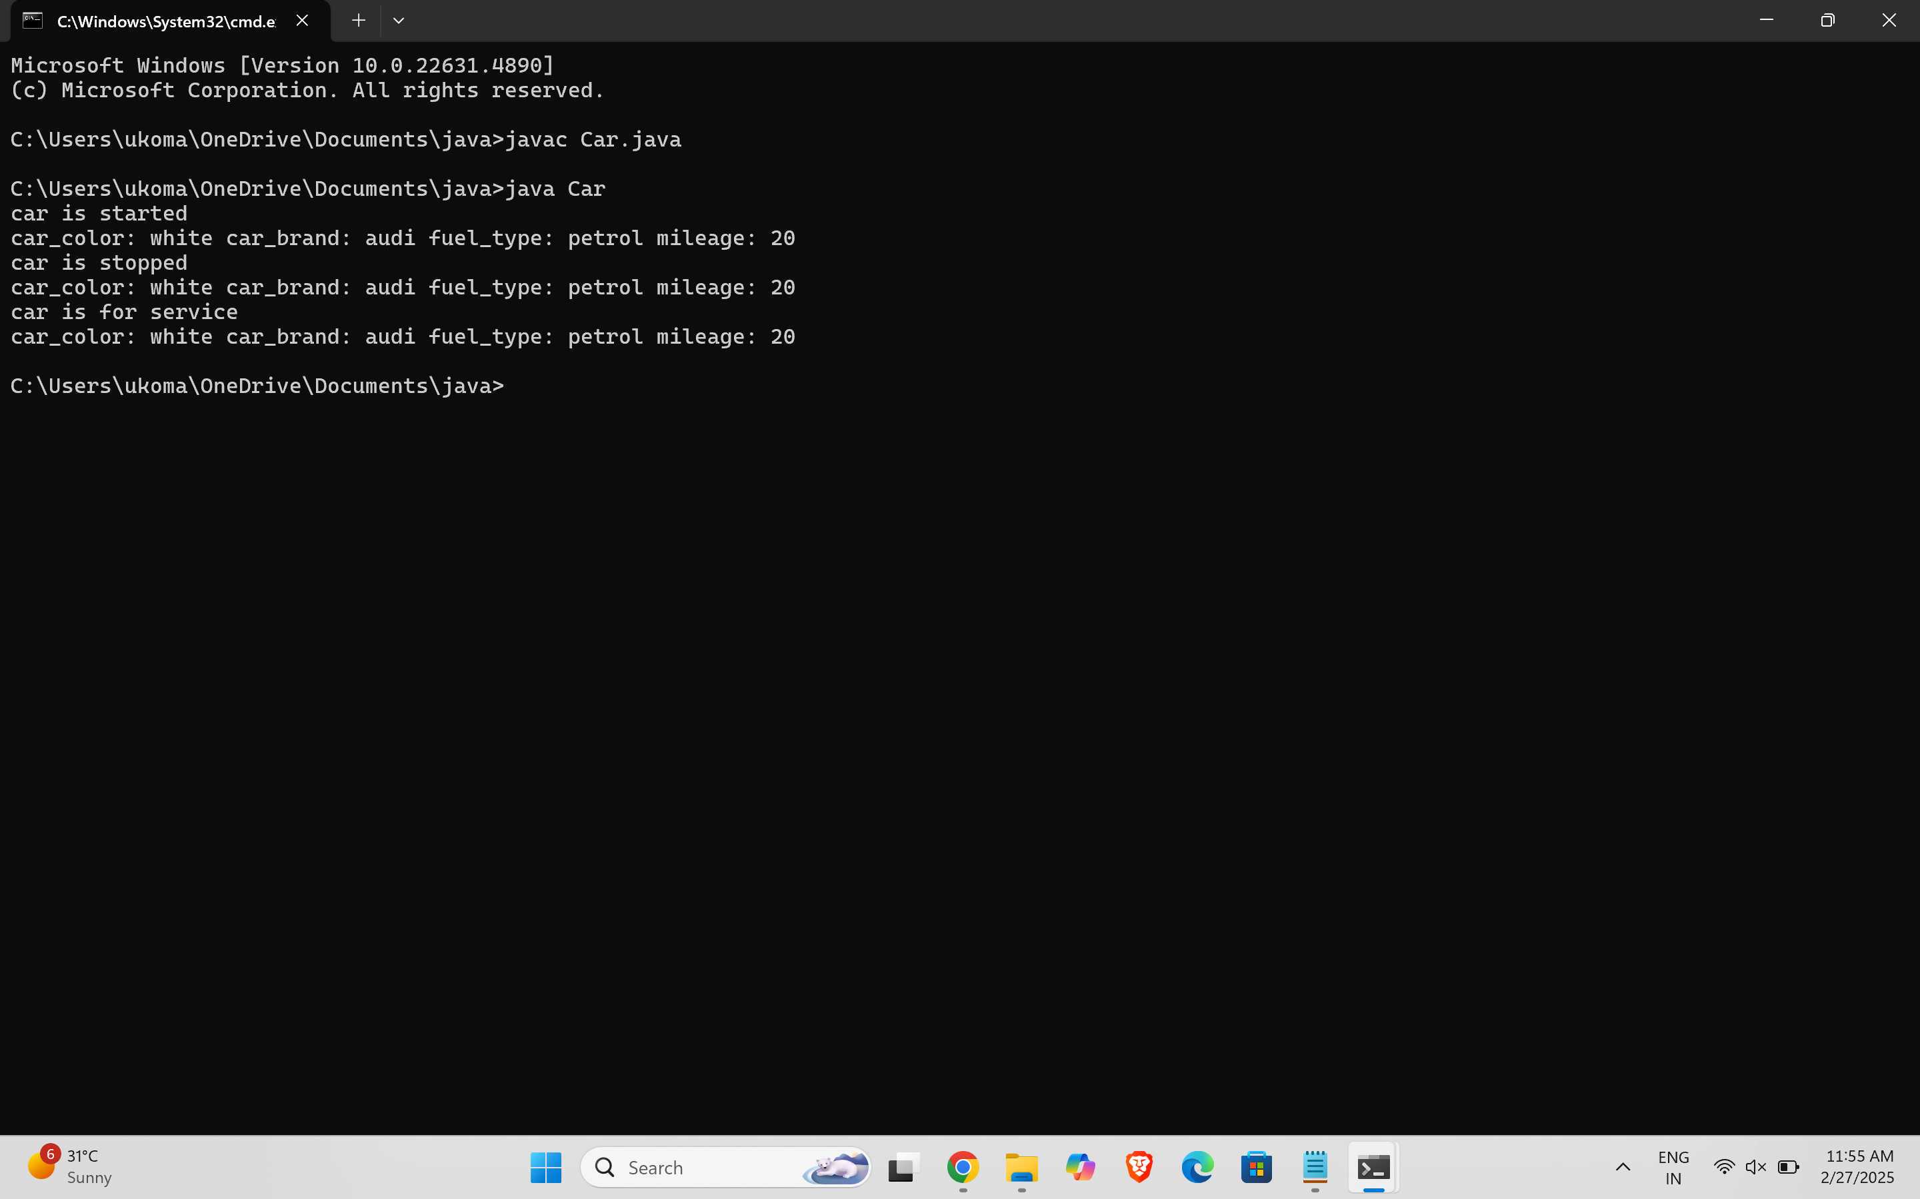

**Error table:**

|  |  |
| --- | --- |
| **Code error** | **Rectification** |
| **Syntax Error** | **‘{‘ added** |
| **Compile time Error** | **Rectified with**  **Correct variable name** |
| **Case sensitive error** | **Rectified** |

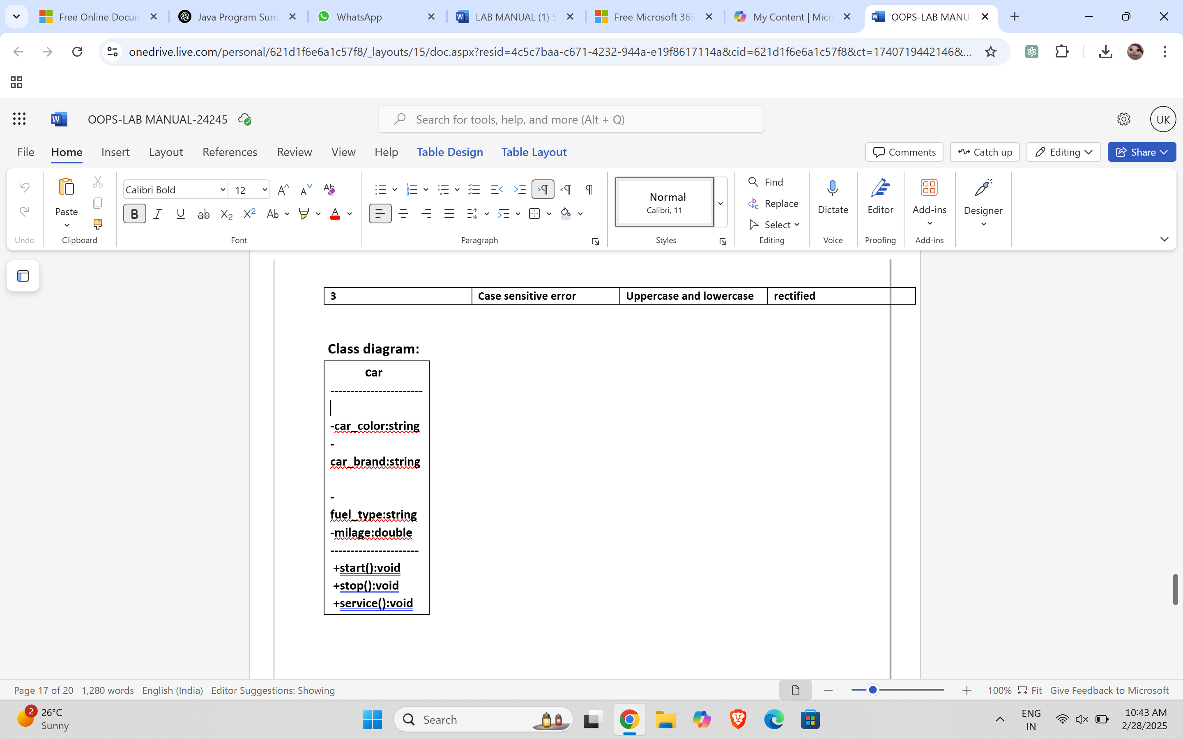

PROGRAM- 2:

AIM: To create a class BankAccount with methods deposit() and withdraw() . create two subclasses savingsaccount and checkingaccount override the withdraw () method in each subclass to impose different withdrawal limits and fees.

CODE:

public class BankAccount {

public double balance;   
  
  
  
public BankAccount(double initialBalance) {   
  
 balance = initialBalance;   
  
}   
  
  
  
public void deposit(double amount) {   
  
 if (amount > 0) {   
  
 balance += amount;   
  
 System.out.println("Deposited " + amount + ". New balance is " + balance);   
  
 } else {   
  
 System.out.println("Deposit amount must be positive.");   
  
 }   
  
}   
  
  
  
public void withdraw(double amount) {   
  
 if (amount > 0 && amount <= balance) {   
  
 balance -= amount;   
  
 System.out.println("Withdrew " + amount + ". New balance is " + balance);   
  
 } else {   
  
 System.out.println("Invalid withdrawal amount. Check your balance.");   
  
 }   
  
}   
  
  
  
public static void main(String[] args) {   
  
 BankAccount account = new BankAccount(100); // Initial balance of 100   
  
   
  
 account.deposit(100000);   
  
 account.withdraw(30000);   
  
 account.withdraw(1500); // Invalid withdrawal   
  
}

**Output:**

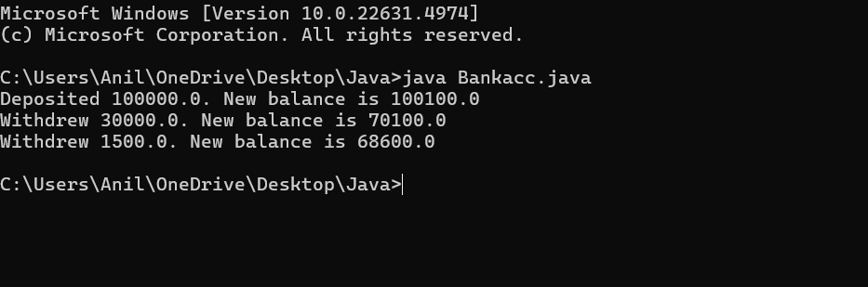  
**Error table:**

|  |  |
| --- | --- |
| **Code error** | **Rectification** |
| **Name Error** | **Correct variable**  **Name replaced** |
| **Syntax Error** | **Parenthesis Added** |
| **Logical Error** | **Condition Rectified** |

CLASS DIAGRAM:

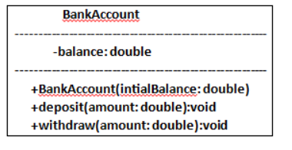

WEEK -4

PROGRAM – 1:

AIM: Write a java program with class named “book”, the class should contain various attributes such as title, author, year of publication it should also contain a constructor with parameters which initializes, title, author, and year of publication.

Create a method which displays the details of the book and display the details of two books.

CODE:

public class book

{

String title;

String author;

int year;

// Constructor

public book(String title, String author, int year) {

this.title = title;

this.author = author;

this.year = year;

}

// Method

public void displayDetails() {

System.out.println("Title: " + title);

System.out.println("Author: " + author);

System.out.println("Year of publication: " + year);

System.out.println();

}

public static void main(String[] args) {

//objects

book book1 = new book("book 1", "author 1", 1999);

book book2 = new book("book 2", "author 2", 2000);

//book details

System.out.println("Book 1 Details:");

book1.displayDetails();

System.out.println("Book 2 Details:");

book2.displayDetails();

}

}  
OUTPUT:

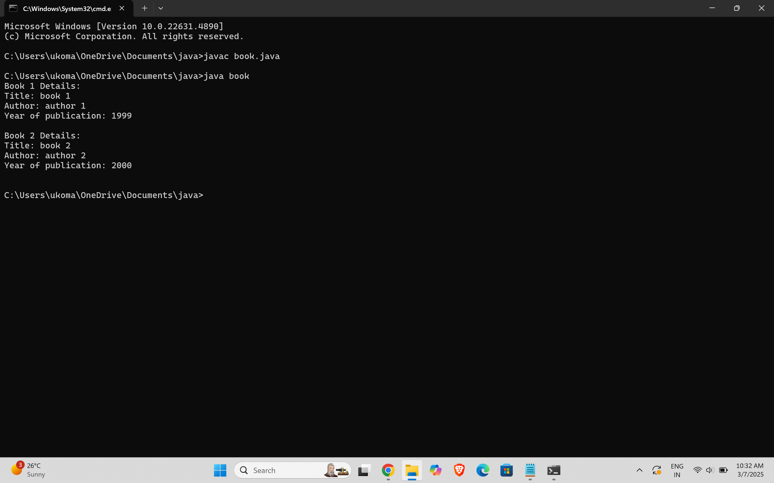

ERROR TABLE:

|  |  |
| --- | --- |
| **Code Error** | **Code rectification** |
| 1. Not defining the function in a file. 2. Two public class files should not be saved in the same file. | 1. To call the method we must define a function in a file. 2. Two public class files should be saved in different files. |

IMPORTANT POINTS:

1. While defining two classes for a code, we must be sure that we save both the classes in separate files.
2. While defining a method we should also define a function to call that method.

CLASS DIAGRAM:

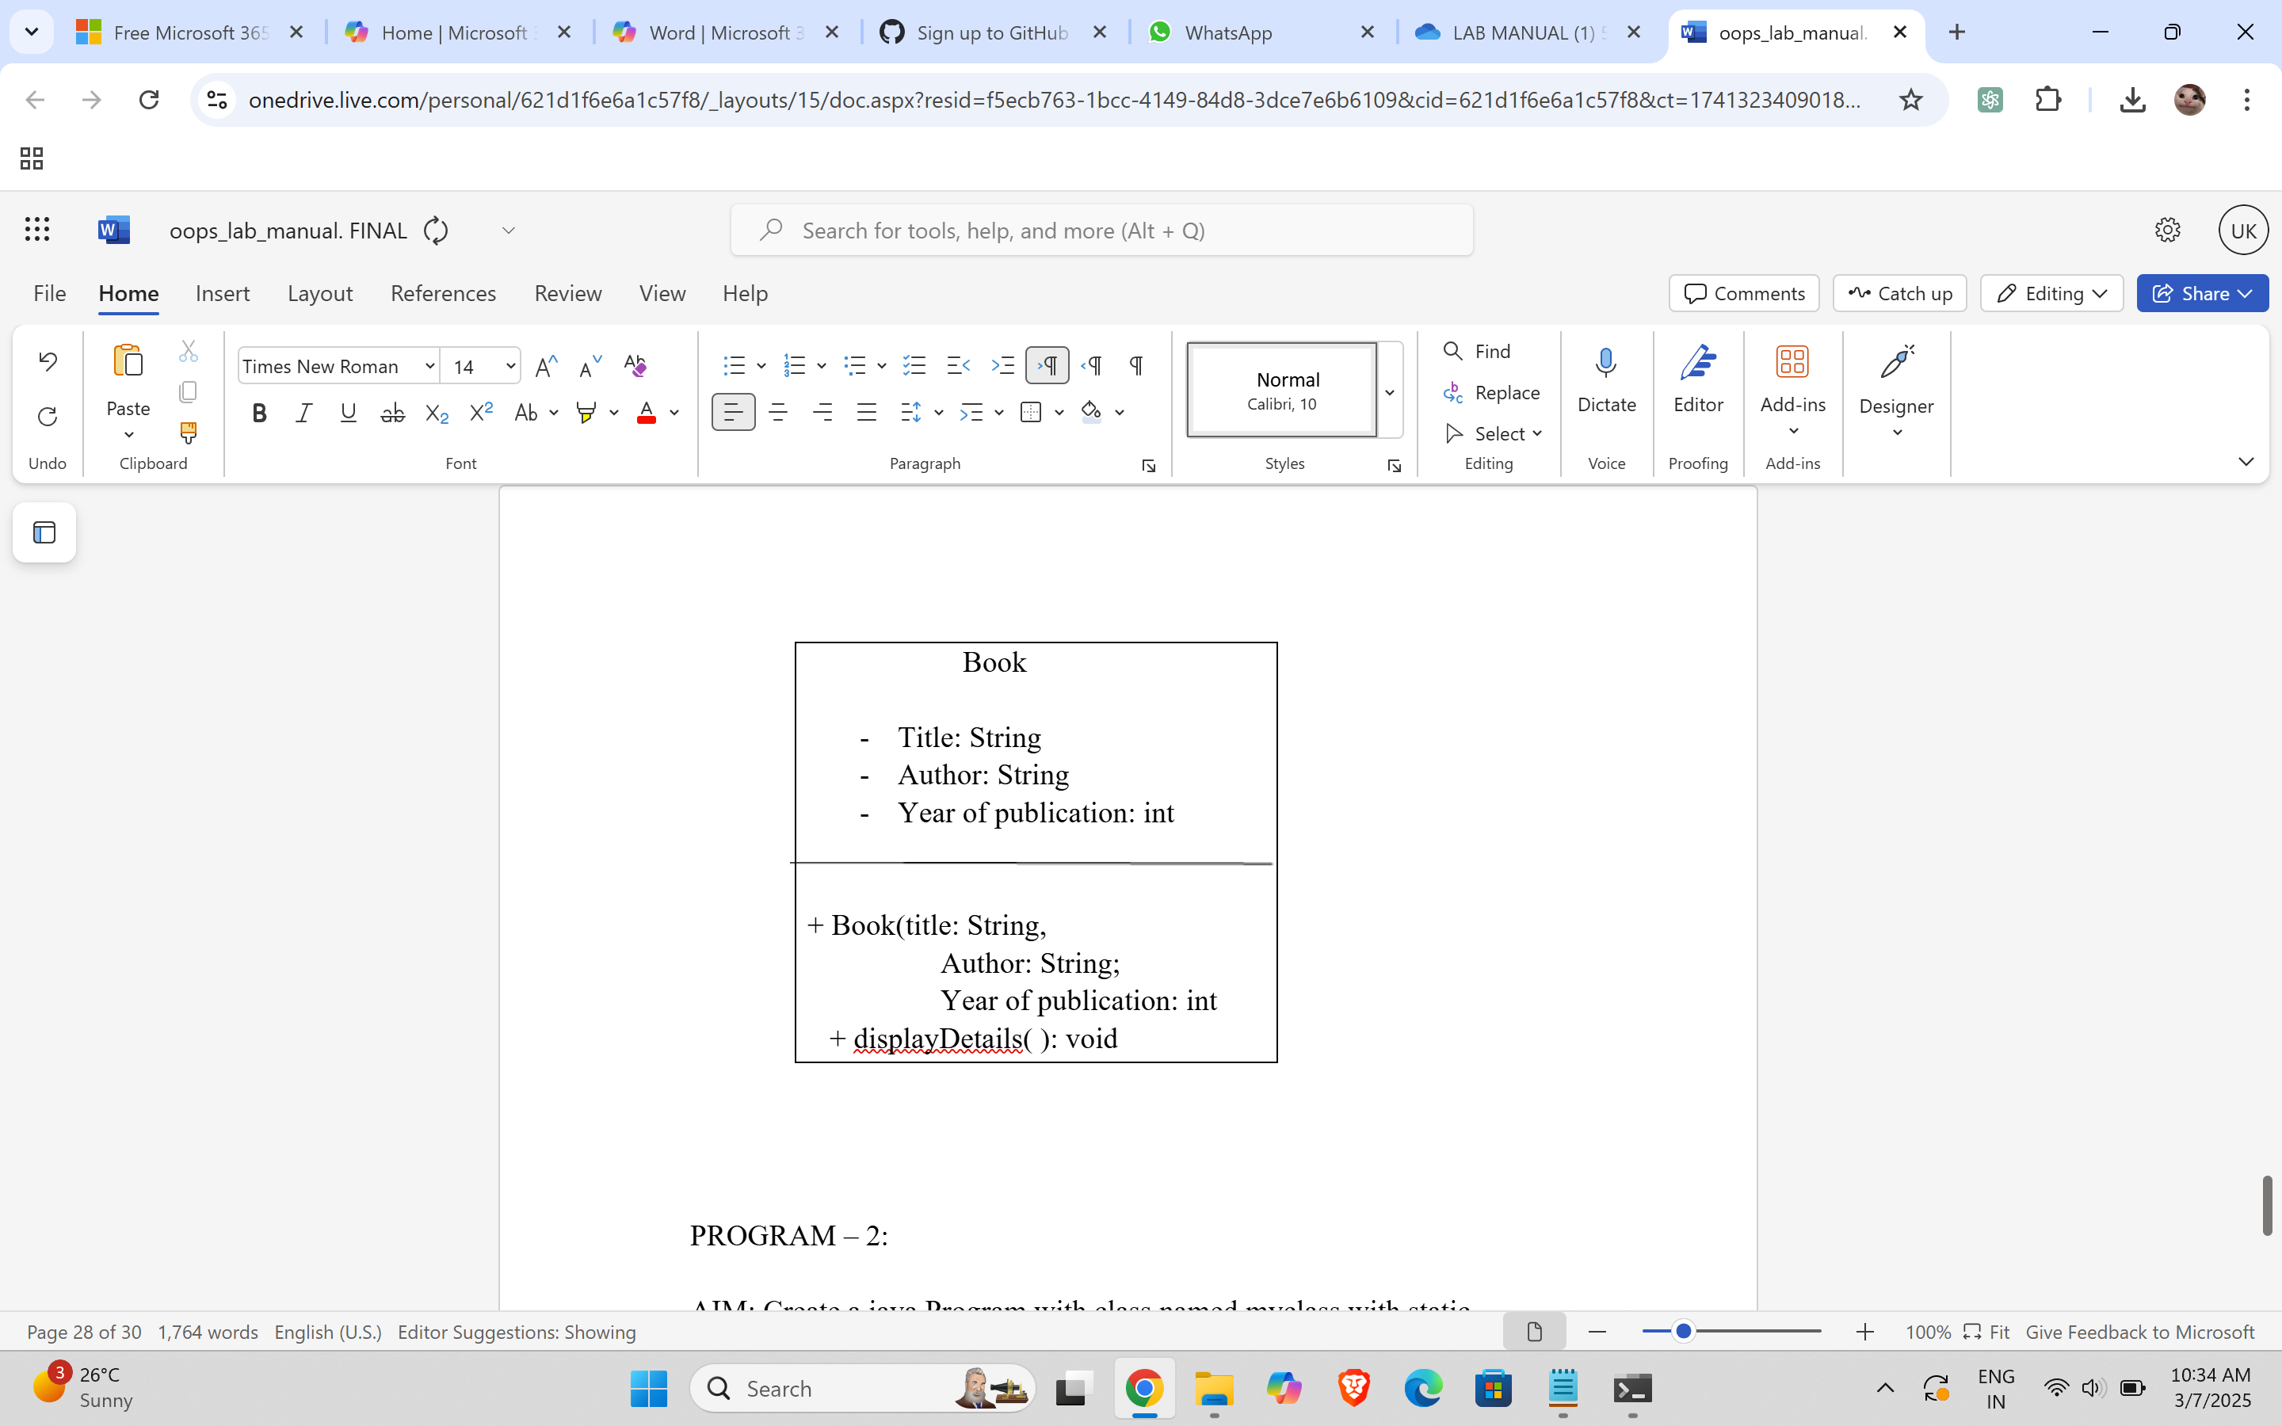

PROGRAM – 2:

AIM: Create a java Program with class named myclass with static variable count of int type, initialized to zero and a constant variable “pi” of type double initialized to 3.14 as attributes of the class, ow define a constructor for “myclass” that increments the count variable each time an object of my class is created (count++), finally print the final values of count and pi variables create three objects.

CODE:

public class myclass

{

static int count = 0;

final double PI = 3.14;

myclass() {

count++;

}

void display() {

System.out.println("Count: " + count);

System.out.println("PI: " + PI);

}

public static void main(String[] args) {

myclass obj1 = new myclass();

myclass obj2 = new myclass();

myclass obj3 = new myclass();

obj3.display();

}

}

OUTPUT:

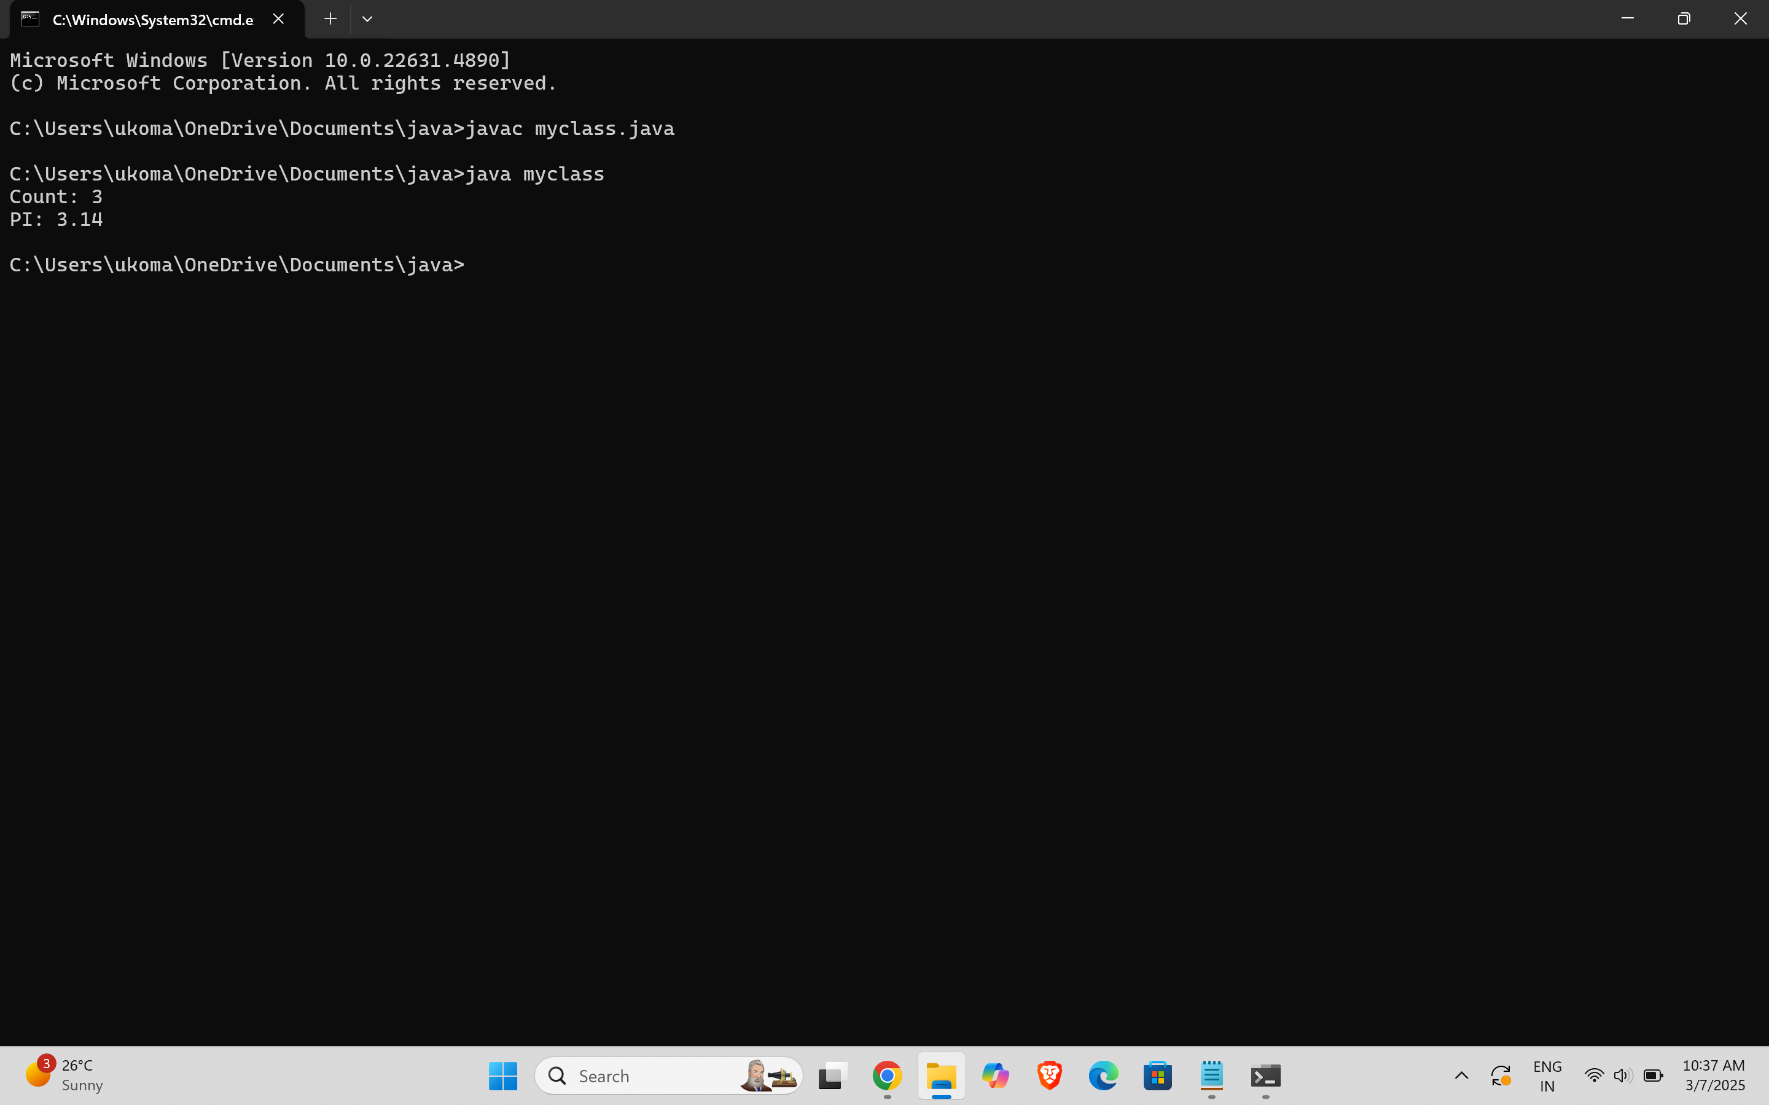

ERROR TABLE:

|  |  |
| --- | --- |
| **Code Error** | **Code rectification** |
| 1. Not Putting the semi-colon after calling a function, 2. Not giving the indentation properly. | 1. Put the semi-colon after calling a function. 2. All the indentation must be correct to run the code correct. |

WEEK-5

PROGRAM-1:

AIM: Create a calculator using the operations including addition, subtraction, multiplication, and division using multi-level inheritance and display the desired output.

Hint: collect required variables using super class,

Create each class for a parameter and each class must contain a method.

CODE:

class calculator {

protected double a, b;

public calculator(double a, double b) {

this.a = a;

this.b = b;

}

}

class Addition extends calculator {

public Addition(double a, double b) {

super(a, b);

}

public double add() {

return a + b;

}

}

class Subtraction extends Addition {

public Subtraction(double a, double b) {

super(a, b);

}

public double subtract() {

return a - b;

}

}

class Multiplication extends Subtraction {

public Multiplication(double a, double b) {

super(a, b);

}

public double multiply() {

return a * b;

}

}

class Division extends Multiplication {

public Division(double a, double b) {

super(a, b);

}

public double divide() {

if (b != 0) {

return a / b;

} else {

System.out.println("Error");

return Double.NaN;

}

}

}

class Final extends Division {

public Final(double a, double b) {

super(a, b);

}

public void displayResults() {

System.out.println("Addition: " + add());

System.out.println("Subtraction: " + subtract());

System.out.println("Multiplication: " + multiply());

System.out.println("Division: " + divide());

}

}

import java.util.Scanner;

public class allcalculator {

public static void main(String[] args) {

Scanner input = new Scanner(System.in);

System.out.println("Enter a number: ");

double a = input.nextDouble();

System.out.println("Enter b number: ");

double b = input.nextDouble();

Final calc = new Final( a, b);

calc.displayResults();

System.out.println("Uday krian");

input.close();

}

}

OUTPUT:

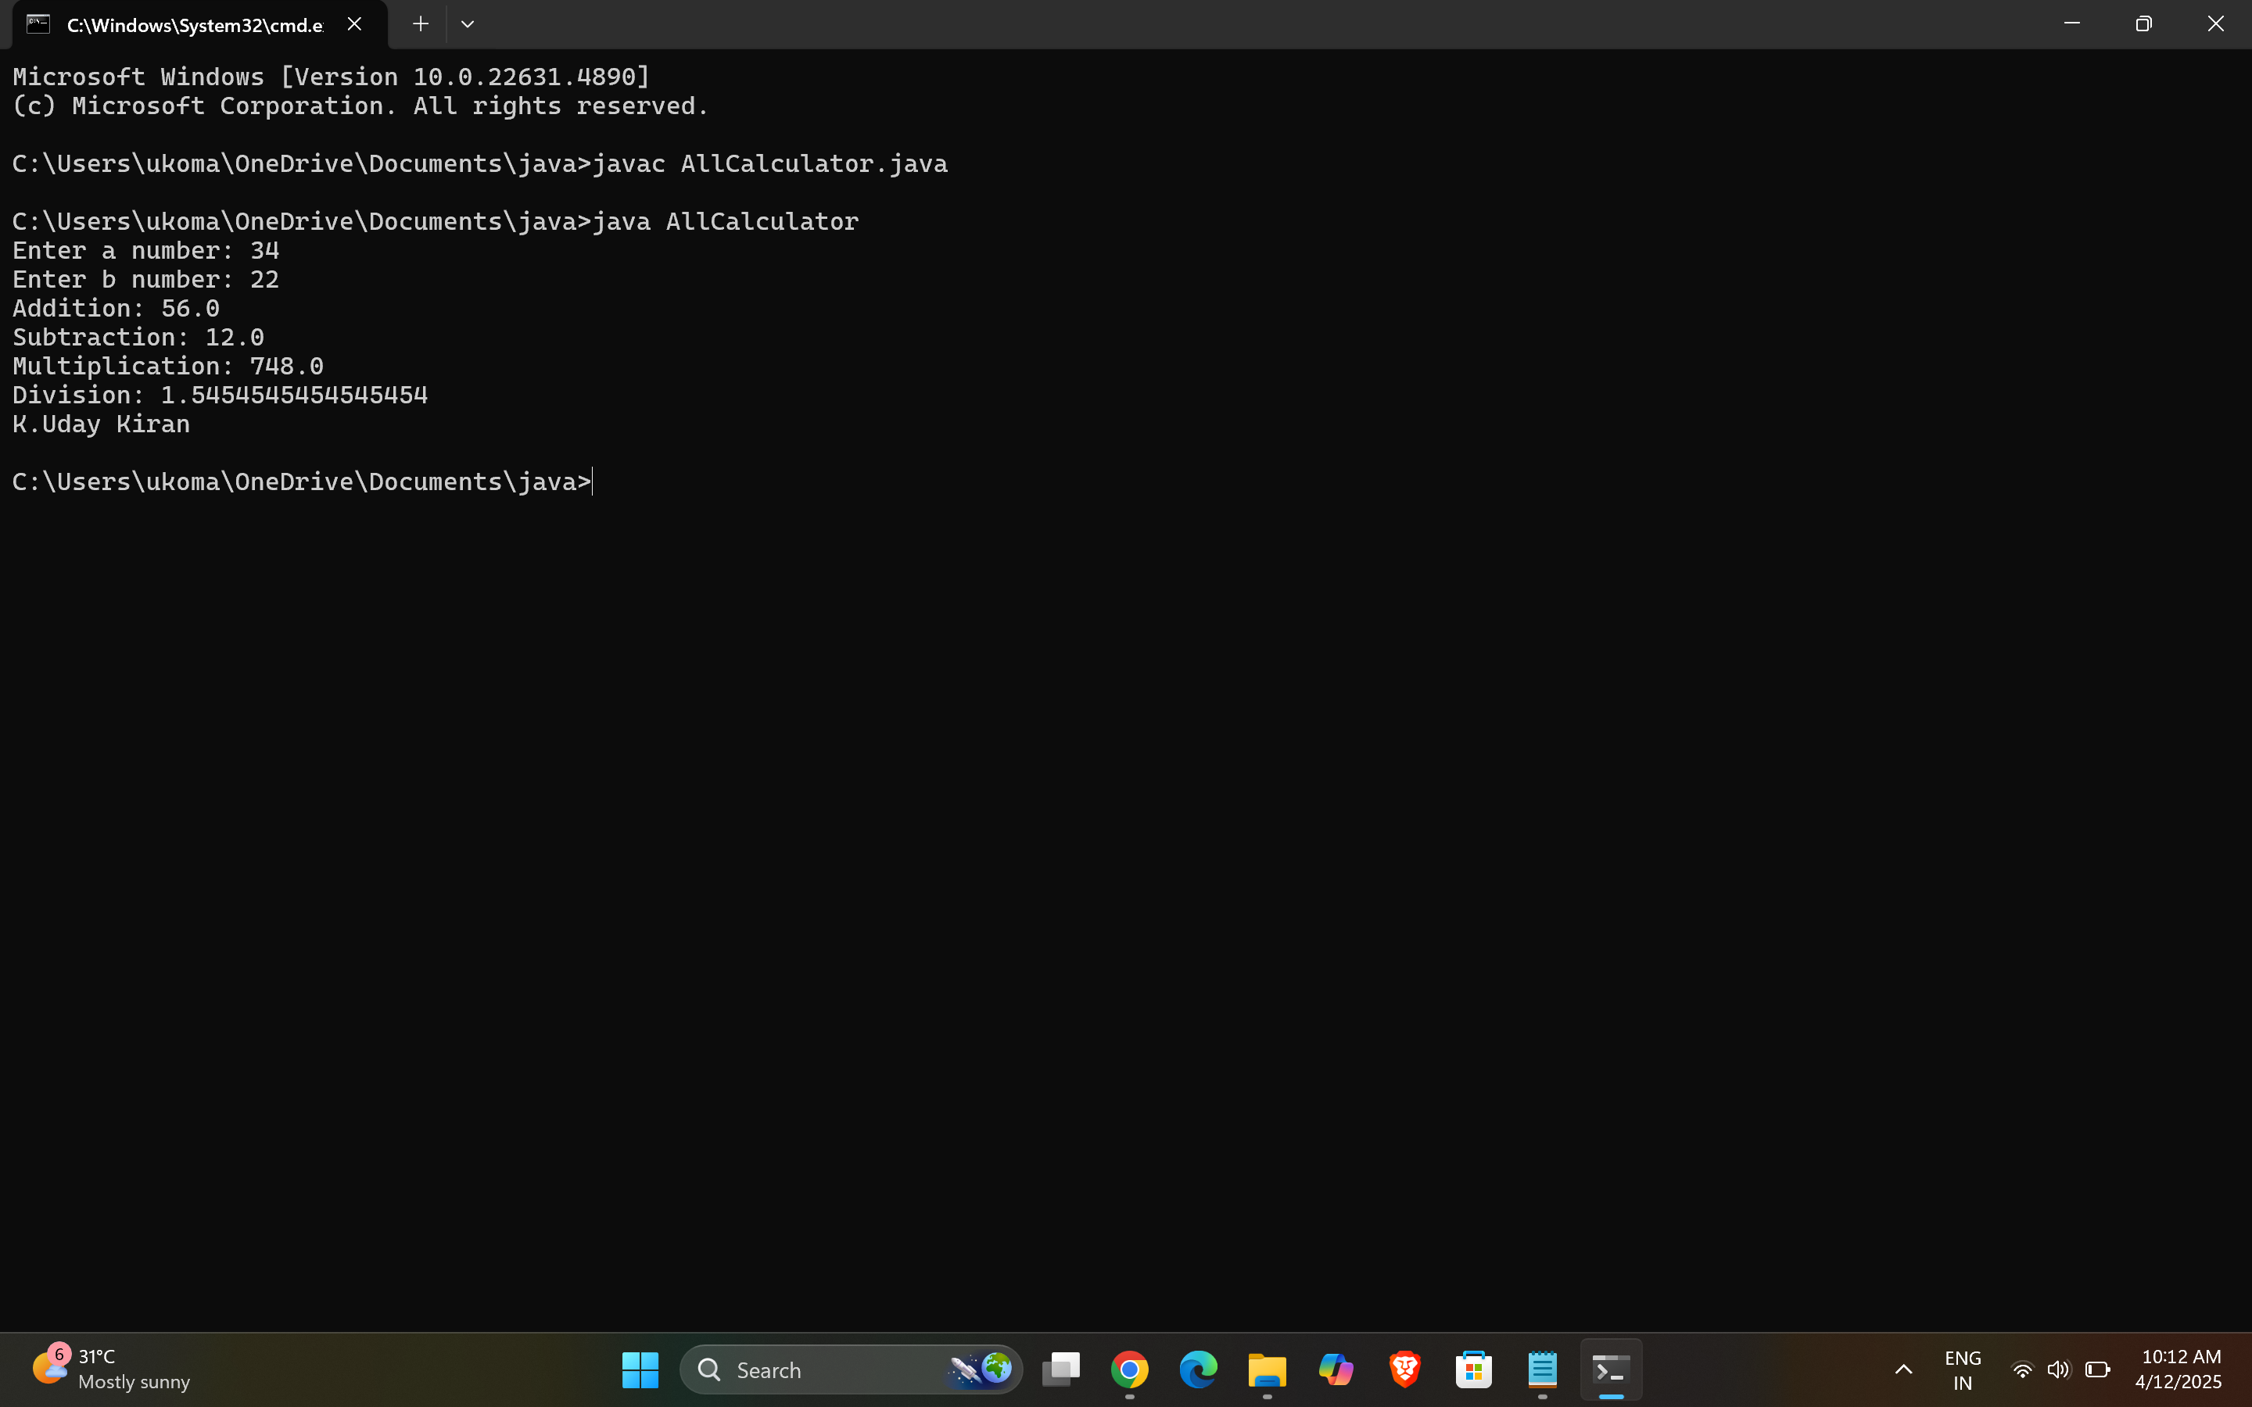

CLASS DIAGRAM:

Calulator



* a : double
* b : double



+ Calculator(a,b)



Addition



+ add(): double



Subtraction



+ subtract(): double



Multiplication



+multiply(): double

Division



+divide(): double

ERROR TABLE:

|  |  |
| --- | --- |
| **Code Error** | **Code rectification** |
| 1. not providing the return method correctly. 2. Not mentioning super to obtain the super class constructor. | 1. After declaring methods, we must provide the return method correctly. 2. To obtain the super class we need to mention super. |

NEGATIVE CASE:

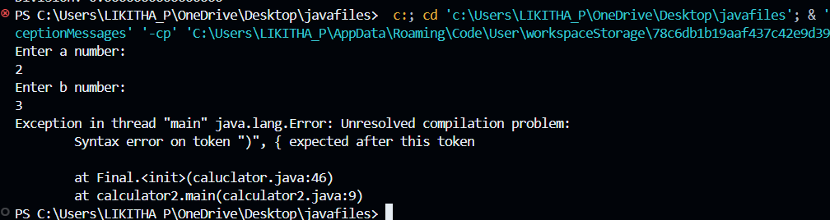

IMPORTANT POINTS:

1. To get the inputs from the user we use import java.util.Scanner; this is a package.
2. Scanner class is used to get the user input.
3. in java.util.Scanner, the java.util is a package while Scanner is a class of the java.util package.
4. to import a whole package, end the sentence with an asterisk sign(*).

PROGRAM-2

AIM: A vehicle rental company wants to develop a system that maintains information about different types of vechicles available for rent the company rents out cars and bikes, and they need a program to store details about each vehicle, such as brand and speed( should be in super class)

1. cars should have an additional property: no.of doors
2. Bikes should have a property indicating whether they have gears or not.
3. The system should also include a function to display details about each vehicle and indicate when a vehicle is starting.
4. Every class should have a constructor

Question:

1. Which oops concept is used in the above program
2. If the company decides to add a new type of vehicle, Truck, how would you modify the program?
3. Truck should include an additional property capacity (in tons)
4. Create a showTruckdetails() method to display the truck’s capacity.
5. Write a constructor for Truck that initializes all properties
6. Implement the truck class and update the main method to create a Truck object and also create an object for car and bike sub classes Finally, display the details.

CODE:

class Vehicle {

public String brand;

public int speed;

public Vehicle(String brand, int speed) {

this.brand = brand;

this.speed = speed;

}

public void start() {

System.out.println(brand + " is starting");

}

public void showDetails() {

System.out.println("Brand: " + brand);

System.out.println("Speed: " + speed + " km/h");

}

}

class Car extends Vehicle {

private int noOfDoors;

public Car(String brand, int speed, int noOfDoors) {

super(brand, speed);

this.noOfDoors = noOfDoors;

}

public void showDetails() {

super.showDetails();

System.out.println("Number of Doors: " + noOfDoors);

}

}

class Bike extends Vehicle {

private boolean hasGears;

public Bike(String brand, int speed, boolean hasGears) {

super(brand, speed);

this.hasGears = hasGears;

}

public void showDetails() {

super.showDetails();

System.out.println("Has Gears: " + (hasGears ? "Yes" : "No"));

}

}

class Truck extends Vehicle {

private int capacity;

public Truck(String brand, int speed, int capacity) {

super(brand, speed);

this.capacity = capacity;

}

public void showTruck() {

super.showDetails();

System.out.println("Capacity: " + capacity + " tons");

}

}

public class Rent {

public static void main(String[] args) {

Car car = new Car("Toyota", 150, 4);

Bike bike = new Bike("Yamaha", 120, true);

Truck truck = new Truck("Volvo", 90, 10);

System.out.println("Car Details");

car.start();

car.showDetails();

System.out.println("Bike Details");

bike.start();

bike.showDetails();

System.out.println("Truck Details");

truck.start();

truck.showTruck();

System.out.println("NAME: K.Uday Kiran");

}

}

OUTPUT:

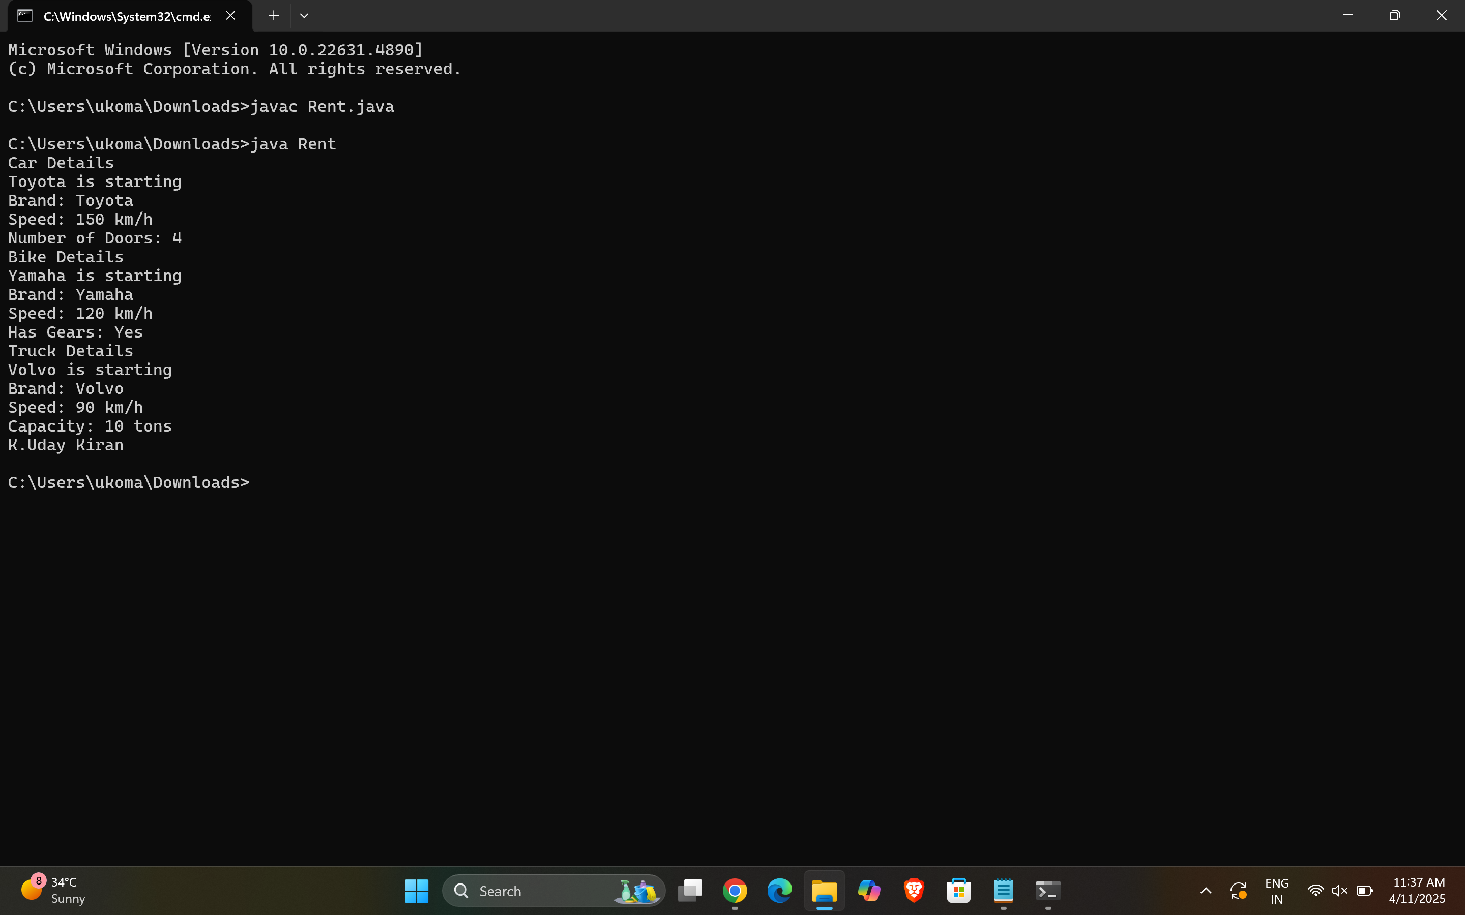

CLASS DIAGRAM:

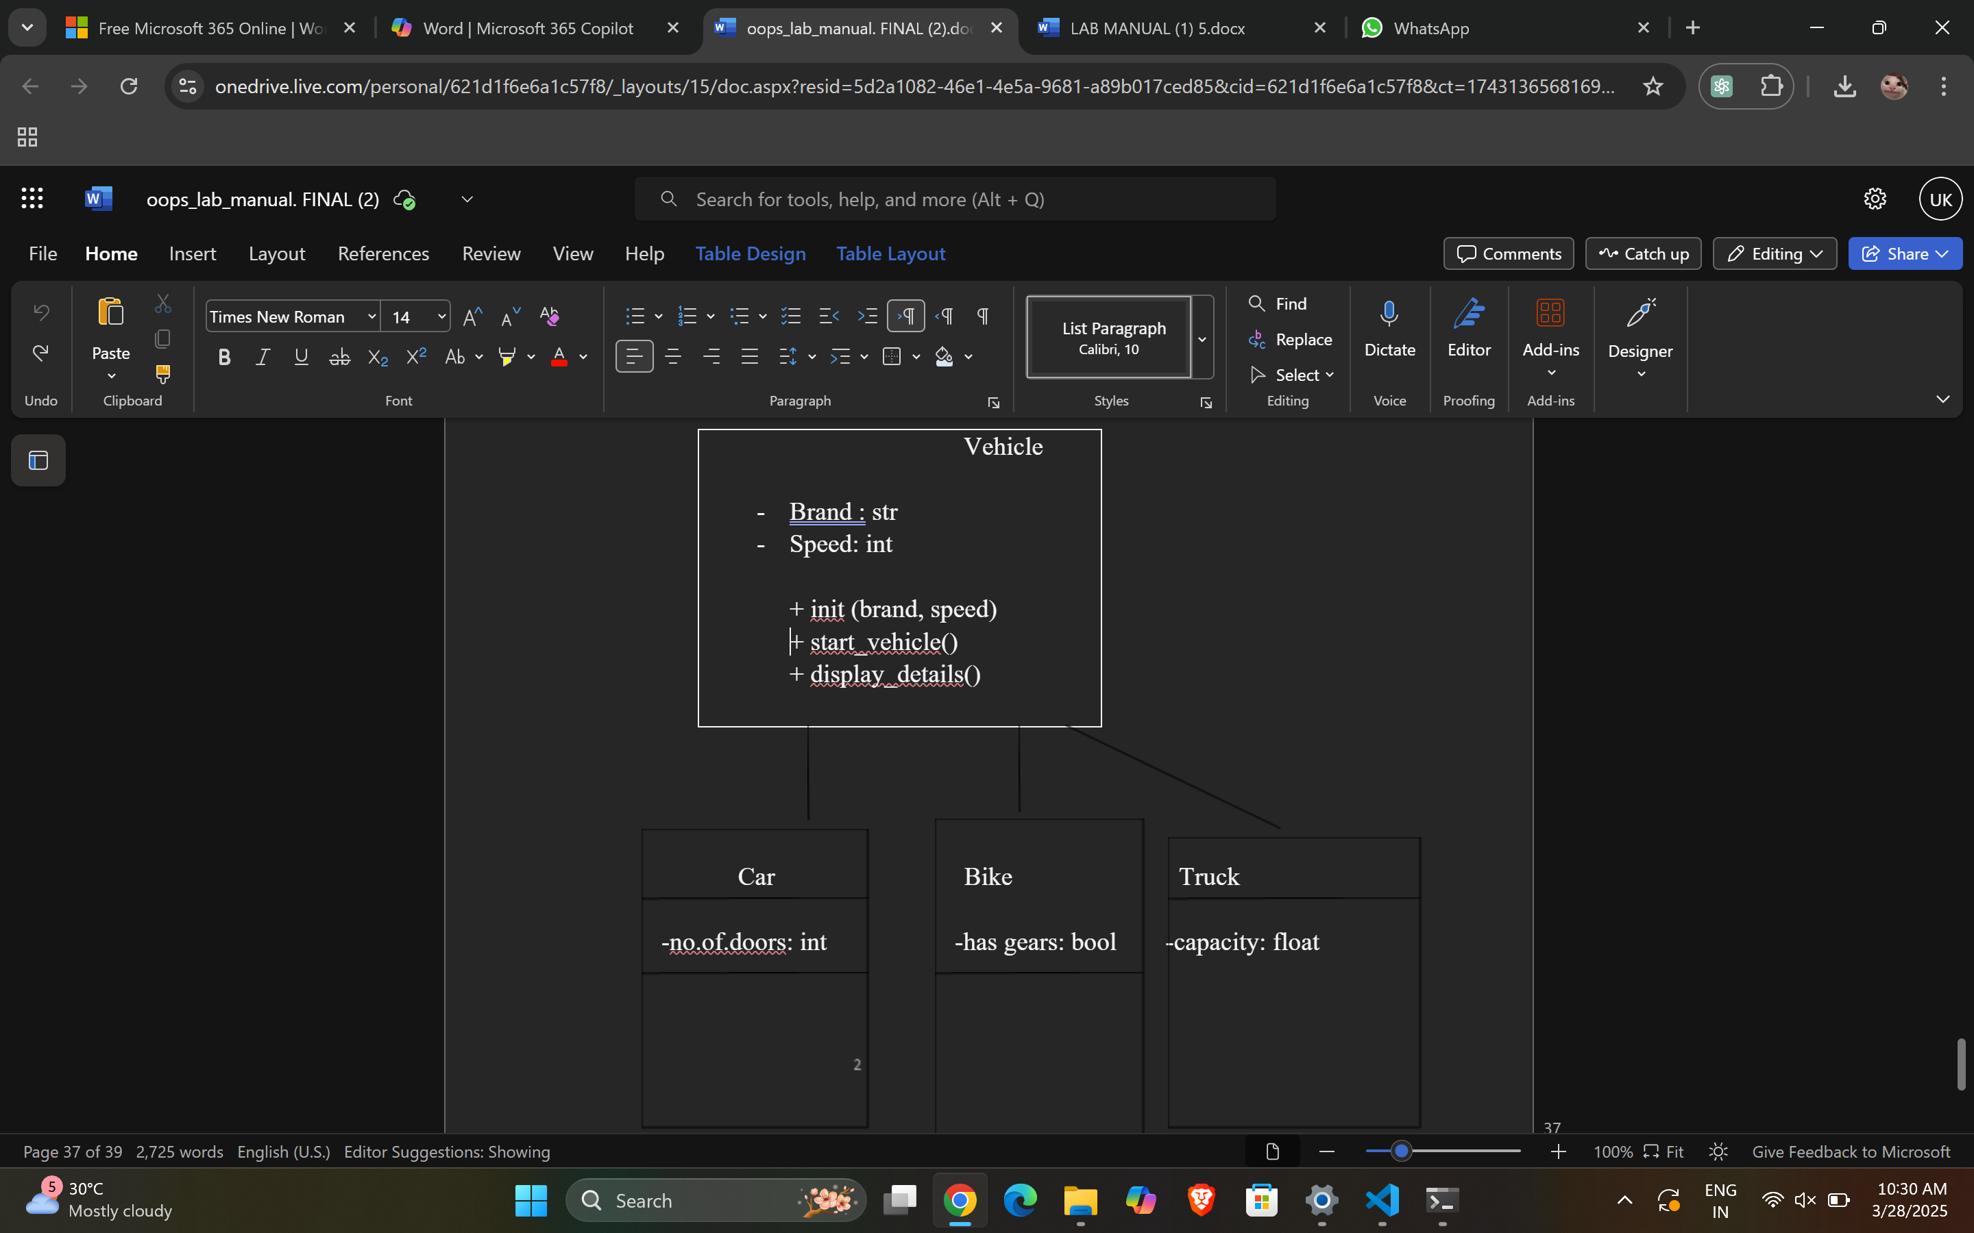

ERROR TABLE:

|  |  |
| --- | --- |
| **Code Error** | **Code rectification** |
| 1. Declaring two superclasses inside the same file. 2. Not declaring the variable using ‘this’ keyword inside the constructor. | 1. Make two separate files to save the two super classes. 2. Declare the variable using this keyword to run the program. |

NEGATIVE CASE:

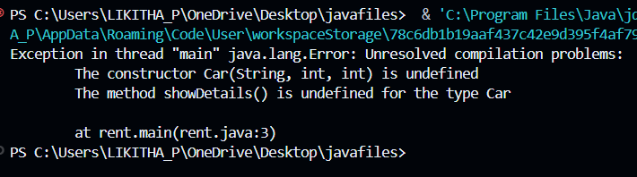

IMPORTANT POINTS:

1. a constructor helps in initializing an object that doesn't exist.
2. a method performs functions on pre-constructed or already developed objects.
3. a double method can represent more decimal point numbers than float method.
4. the void keyword in java is used to specify that a method does not return any value. it is a return type that indicates the method performs a function and doesn't produce a result.

Answer:

The oops concepts used in the above program are:

Inheritance, encapsulation, polymorphism, abstraction.

To add a new vehicle type truck we need to create a truck class that will:

* Include an additional property capacity (in tons).
* Implement a showtruckdetials() method to display the truck's capacity.
* Implement a constructor for the truck class to initialize all its properties.

**WEEK-6**

**PROGRAM-1:**

**AIM:** Write a java program to create a vehicle class with a method displayinfo(). Override this method in the car subclass to provide specific information about a car.

**Code:**

class Vehicle {

public String carmodel;  
public String color;  
public String fuel_type;  
  
public Vehicle(String carmodel, String color, String fuel_type) {  
 this.carmodel = carmodel;  
 this.color = color;  
 this.fuel_type = fuel_type;  
}  
  
public void displayinfo() {  
 System.out.println("Car Model: " + carmodel);  
 System.out.println("Car color: " + color);  
 System.out.println("Car fuel type: " + fuel_type);  
 System.out.println("I own a BMW.");  
}

}

class Car extends Vehicle {

public Car(String carmodel, String color, String fuel_type) {  
 super(carmodel, color, fuel_type);  
}  
  
public void displayinfo() {  
 super.displayinfo();  
 System.out.println("I own an Audi.");  
}

}

public class Vehiclefunction {

public static void main(String[] args) {  
  
 System.out.println("K.Uday kiran");  
  
 Vehicle v = new Vehicle("Audi", "White", "Petrol");  
 v.displayinfo();  
  
 Car c = new Car("Benz", "Black", "Diesel");  
 c.displayinfo();  
}

}

Output:

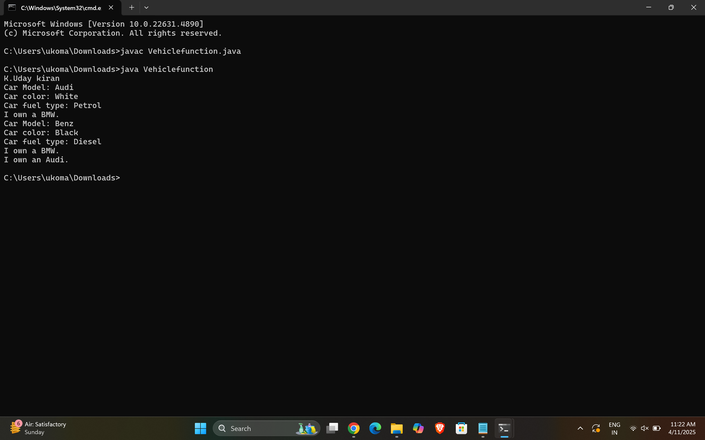

**CLASS DIAGRAM:**

|  |
| --- |
| Vehicle |
| - brand: String  - speed: int  ---------------------------  + Vehicle(brand: String,  speed: int)  + startVehicle(): void  + displayDetails(): void |

ERROR TABLE:

|  |  |
| --- | --- |
| **Code Error** | **Code rectification** |
| |  | | --- | | **1.Incorrect class namefor**main**method **(****Truck****)**** | | **2.Inconsistent car model output in**displayInfo() | | |  | | --- | | 1.Rename Truck to Main or place main inside Car or Vehicle. | | 2.Ensure Car correctlypasses  Benz" to super(car_model,  color, fuel_type);. | |

NEGATIVE CASE:

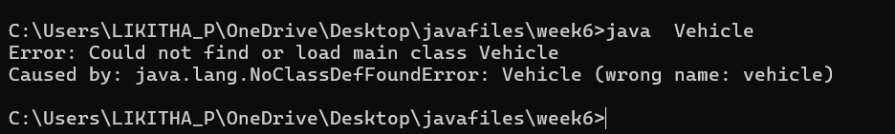

Important points:

1. **Inheritance** allows the Car class to reuse the Vehicle class functionality without repeating code.

2. **Method Overriding** enables the Car class to provide its own implementation of the displayInfo() method.

3. **Polymorphism** makes the code flexible, allowing different classes (e.g., Car, Bike) to provide customized behavior for displayInfo().

**PROGRAM-2:**

AIM: A college is developing an automated admission system that verifies student eligibility for UG and PG programs. Each program has different eligibility criteria based on the student’s percentage in their previous Qualification:

UG admissions require a minimum of 60%

PG admissions require a minimum of 70%

Code:

import java.util.Scanner;

public class Admission {

public static void main(String[] args) {

Scanner input = new Scanner(System.in);

System.out.print("Enter student name: ");

String name = input.nextLine();

System.out.print("Enter qualification percentage: ");

double percentage = input.nextDouble();

input.nextLine(); // consume the leftover newline

System.out.print("Enter program (UG/PG): ");

String program = input.nextLine();

if (program.equalsIgnoreCase("UG")) {

if (percentage >= 60) {

System.out.println(name + " is eligible for UG admission.");

} else {

System.out.println(name + " is not eligible for UG admission.");

}

} else if (program.equalsIgnoreCase("PG")) {

if (percentage >= 70) {

System.out.println(name + " is eligible for PG admission.");

} else {

System.out.println(name + " is not eligible for PG admission.");

}

} else {

System.out.println("Invalid course entered.");

System.out.println("K.Uday kiran");

}

input.close();

}

}

Output :

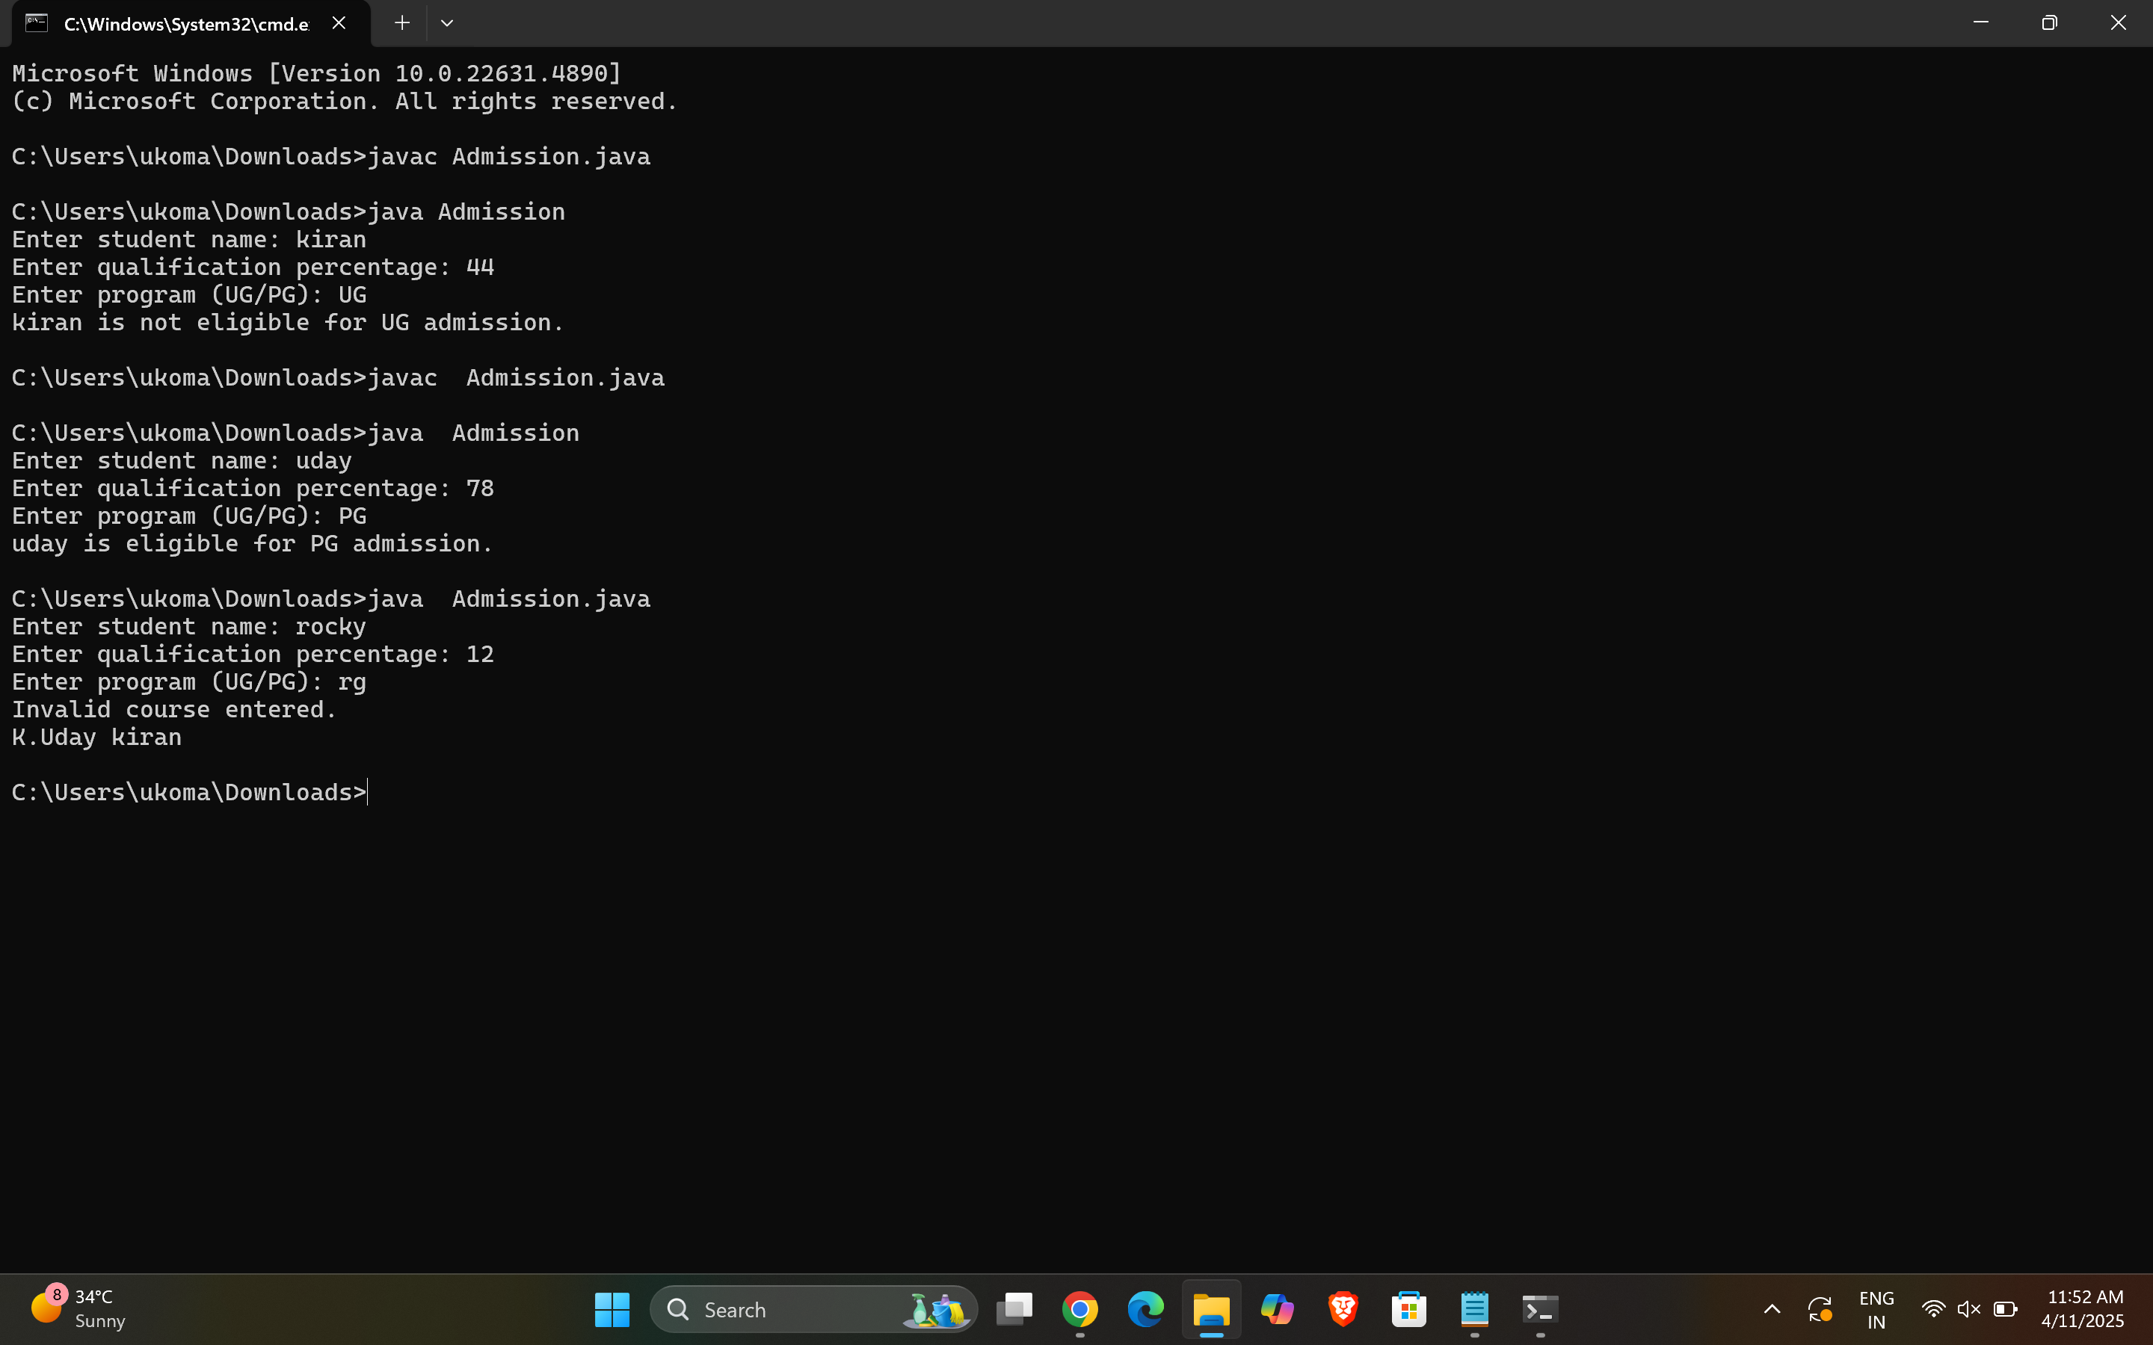

Class diagram :

|  |
| --- |
| Admission System |
| -scanner:Scanner  - name: String  - percentage: double  - program: String  + main(args: String[]): void  + takeInput(): void  + checkEligibility(): void  + closeScanner(): void |

ERROR TABLE:

|  |  |
| --- | --- |
| **Code Error** | **Code rectification** |
| |  | | --- | | ****1.Scanner nextLine() issue after nextDouble()****: After scanner.nextDouble(), the newline character remains in the buffer, causing nextLine() to be skipped. | | ****2.Program type input case sensitivity issue****: If the user enters ug or pg in lowercase, it may cause incorrect comparisons. | | |  | | --- | | 1.Add scanner.nextLine(); after nextDouble(); to consume the leftover newline. | | 2.Use program.toUpperCase() to ensure case-insensitive comparison. | |

NEGATIVE CASE:

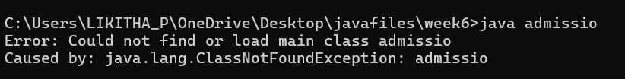

IMPORTANT POINTS:

1.**Inheritance** allows PG and UG classes to reuse the University class’s attributes and constructor.

2. **Method Overriding** customizes the office() method in PG and UG classes to implement specific admission criteria.

3. **Polymorphism** enables the same office() method to behave differently for PG and UG objects based on their type

**PROGRAM-3:**

**AIM:** Create a shape class with a method CalculateArea() that is overloaded for different shpaes (e.g square, rectangle) then, create a subclass circle that overrides the calculatearea() method for a circle.

Code:

public class Shape {

void calcArea(double side) {  
 System.out.println("Area of Square: " + (side * side));  
}  
  
void calcArea(double length, double breadth) {  
 System.out.println("Area of Rectangle: " + (length * breadth));  
}

}

class Circle extends Shape {

void calcArea(double radius) {  
 System.out.println("Area of Circle: " + (3.14 * radius * radius));  
}

}

class Area { public static void main(String[] args) { Shape obj1 = new Shape(); obj1.calcArea(12); obj1.calcArea(4, 9);

Circle obj2 = new Circle();  
 obj2.calcArea(15);  
}

}

OUTPUT:

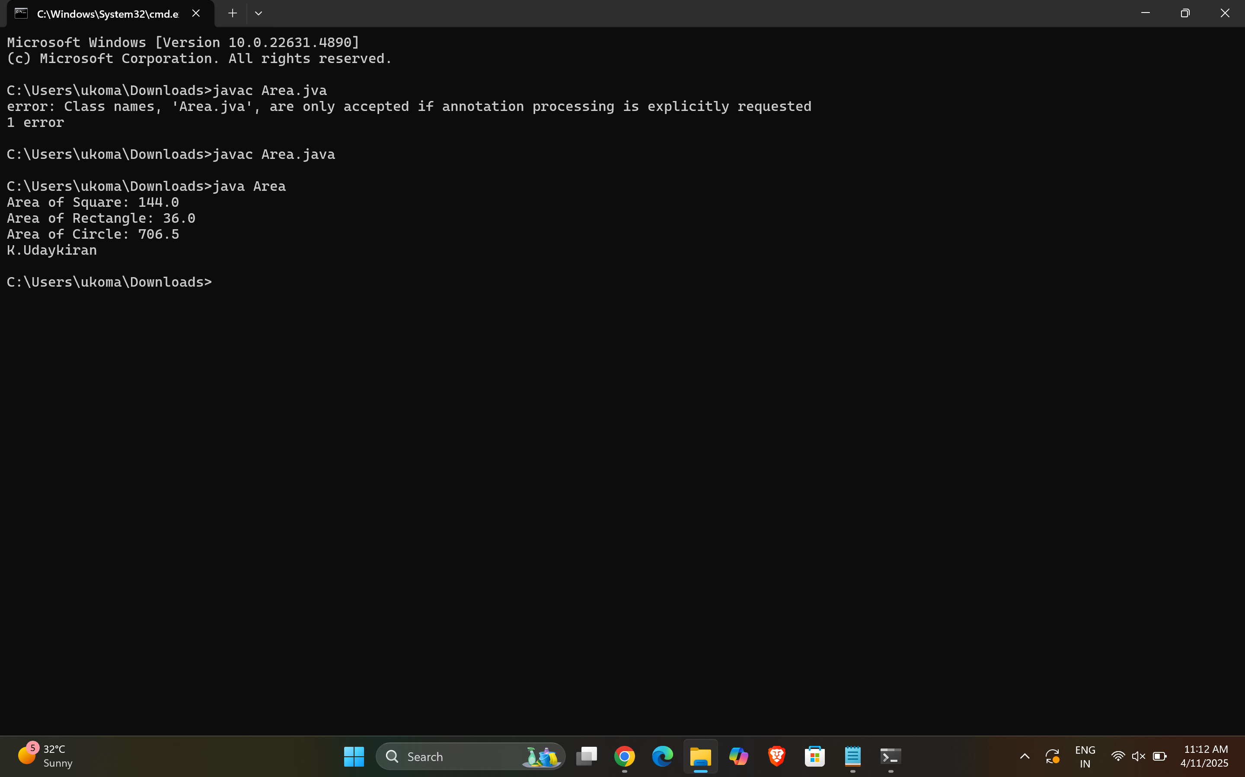

**Claas diagram :**

|  |
| --- |
| **Class shapes** |
| **+ calculateArea(int, int): void**  **+ calculateArea(double, double): void**  **+ calculateArea(int): void** |



|  |
| --- |
| Class circle |
| + calculateArea(double): void |



|  |
| --- |
| Area |
| + main(String[]): void |

ERROR TABLE:

|  |  |
| --- | --- |
| **Code Error** | **Code rectification** |
| |  | | --- | | **1.Method calls in main are missing an object reference** | | **2.Circle class method does not override theparent class method properly.** | | |  | | --- | | 1.Use s.calculateArea(4) and c.calculateArea(2) to call the method correctly. | | 2.Ensure @Override is used, and  the method signature should match correctly. | |

IMPORTANT POINTS :

1. **Method Overloading** allows the Shape class to calculate areas for different shapes (rectangle, triangle, square) using multiple calculateArea() methods with different parameters.
2. **Method Overriding** in the Circle class provides a custom implementation of calculateArea() for calculating the area of a circle.
3. **Polymorphism** enables objects of different types (e.g., Shape, Circle) to call the appropriate version of calculateArea() based on the object type and input parameters.

**PROGRAM-4:**

**AIM:** Create a calculator class with overloaded methods to perform addition.

1. Add two integers
2. Add two double

Add three integer

**CODE:**

public class Calculator {

public int add(int a, int b) {

return a + b;

}

public double add(double a, double b) {

return a + b;

}

public int add(int a, int b, int c) {

return a + b + c;

}

}

public class caluclatorfunction {

public static void main(String[]args) {

Calculator c = new Calculator();

System.out.println("Addition of two integers: " + c.add(2,4));

System.out.println("Addition of two doubles: " + c.add(3.5,6.5));

System.out.println("Addition of three integers: " + c.add(3,4,5));

System.out.println("K.Uday kiran");

}

}

Output:

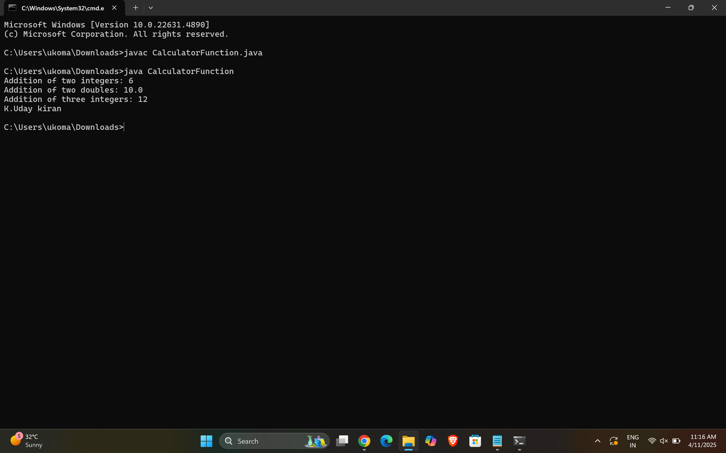

**CLASS DIAGRAM:**

|  |
| --- |
| Calculator |
| +add(int, int): int  +add(double, double): double  +add(int, int, int): int  +main(String[]): void |

ERROR TABLE:

|  |  |
| --- | --- |
| **Code Error** | **Code rectification** |
| 1. Method parameters missing spaces   2. Inconsistent indentation in method bodies | 1. Add proper spacing between 2.Fix indentation |

NEGATIVE CASE :

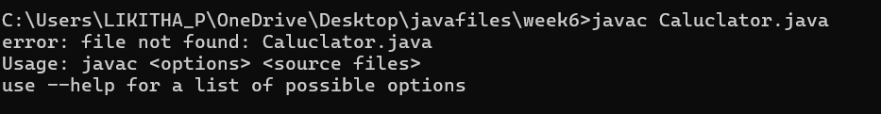

**IMPORTANT POINTS:**

**1.Method Overloading:** The add method is overloaded with different parameter types and counts, demonstrating compile-time polymorphism.

**2.Automatic Method Selection:** Java selects the appropriate add method based on the argument types during compilation.